Date of preparing: 8/12/2024 Period: 43
Date of teaching: 10/12/2024 Week: 15
Lesson 3: UNIT 6: LIFESTYLES -A CLOSER LOOK 2
Timing: 1 period (45 minutes)
I. Objectives
1.Knowledge: By the end of this unit students can:
- use the future simple and first conditional
2. Competence
- Develop communication skills and creativity
- Be collaborative and supportive in pair work and teamwork
- Actively join in class activities
3. Attitude
Students can develop communication skills and creativity, be collaborative and supportive in pair work and teamwork and actively join in class activities
II. Teaching aids (& materials)
- Student book TA 8, ppt file, computer connected to the Internet
- Projector / TV
III. Procedure
Activity 1: Introducing the future simple and first conditional (5 minutes)
Goal | The activity aims at providing the forms of future simple and first conditional.
Input | - Teacher ask Ss if they remember the future simple they have learned in Tieng Anh 6 and Tieng Anh 7.  - Teacher gives example “If I fail the test, I will have to take the course again?”
Procedure | - Teacher reminds students that they have already learned The future simple and First conditional.  - Tell them to read the Remember! box in pairs (p. 63, 64)  Teacher explains again the form and use of future simple and first conditional.
Outcome | 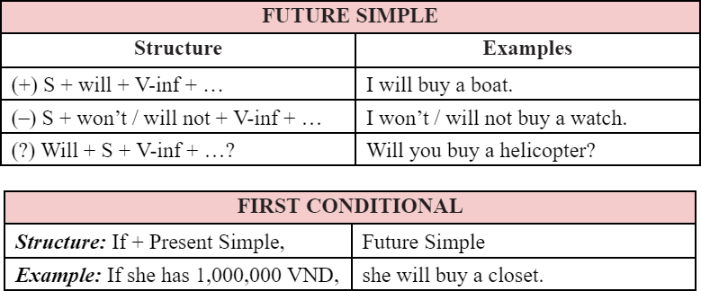
Activity 2 : Use the verbs from the box with will or won’t to complete these dialogues. (5 minutes)
Goal | The activity aims at revising the future simple to complete the given dialogues
Input | - Have Ss study the example first.
Procedure | - Give Ss to work by themselves and write down the answer.  - Teacher observe and help when and where necessary.  - Ask Ss to read their sentences. Call on some Ss to write their answers on the board. Confirm the correct answers.  – Explain to Ss another use of the future simple to describe future possibilities or conditions and give example before moving onto 2.
Outcome | Expected answers:  - will tell  - will attend - won’t join  - won’t have - will do
Activity 3 : Arrange these words and phrases in the correct order to form meaningful sentences.
(10 minutes)
Goal | The activity aims at practicing the future simple.
Input | - Tell Ss to pay attention to the form of the future simple.
Procedure | - Have Ss work individually. Tell them to put the words in correct order to build meaningful sentences.  - Lets Ss work in pairs to compare their answers before sharing their answers.  - Checks and confirms the correct answers.
Outcome | Expected answer:  - We will take our first-term exams very soon.  - Will they stay in an igloo when they visit Alaska?  - She will work with the tribal groups to help them revive their culture.  - I won’t choose online learning in the second semester.  - I’ll come to see you if I go to London this summer.
Activity 4 : Give the correct tense of the verbs in brackets, using the first conditional. ( 10 minutes)
Goal | The activity aims at using the first conditional
Input | - Draw Ss’ attention to the form and use of the first conditional: main clause (future simple) and if-clause (present simple).
Procedure | - Have Ss look at the sentences and write down their answers.  - Teacher asks Ss to check their answers with their partners. Ask for translation of some of the words to check their understanding.  - Teacher confirms the correct answers.
Outcome | Expected answers:  - eat  - goes  - will have  - don’t do  - Will she be
Activity 5 : Fill in each blank with IF or UNLESS ( 5 minutes)
Goal | The activity aims at using If or Unless
Input | - Draw Ss’ attention to the form and use of Unless means If.… not or except if
Procedure | - Have Ss do the exercise individually and then exchange their answers with a partner.  - Call on some Ss to read the sentences aloud. Other Ss comment.  - Teacher confirms the correct answers.
Outcome | Expected answers:  - Unless  - if  - unless  - If  - unless
Activity 6: Complete the following sentences to make them true for students ( 5 minutes)
Goal | The activity aims at applying the uses of the first conditional with if and unless in real contexts by making sentences about themselves.
Input | - Draw Ss’ attention to the form and use of If and Unless again
Procedure | - Give them some time to work independently and write down their sentences.  - Then let them work in pairs to exchange their sentences.  - Teacher goes round giving help when and where necessary.  Some Ss may write their answers on the board. Other Ss comment and teacher makes corrections.
Outcome | Expected answers:  - If it rains tomorrow, I will stay at home.  - Unless I get good marks, I will be upset.  - If I have free time this weekend, I will visit my grandparents  - If I study harder, I will get good marks.  - Unless I go to bed early, I will be tired tomorrow.

Wrap-up: ( 5 minutes)
Ask Ss to summarize what they have learnt in the lesson. Have Ss look at the objectives written on the board at the beginning of the lesson and tick the objectives they have learnt.

Date of preparing: 8/12/2024 Period: 44
Date of teaching: 10/12/2024 Week: 15
Lesson 4: UNIT 6: LIFESTYLES -COMMUNICATION
Timing: 1 period (45 minutes)
I. Objectives:
1. Knowledge: By the end of this unit students can:
- express certainty
- Competence
- Develop communication skills and creativity
- Be collaborative and supportive in pair work and teamwork
- Actively join in class activities
3. Attitude
- Be ready and confident in real life conversations.
II. Teaching aids (& materials)
- Student book TA 8, ppt file, computer connected to the Internet
- Projector / TV
III. Procedure
Activity 1: Introducing ways of expressing certainty (5 minutes)
Goal | The activity aims at helping Ss how to know using express certainly.
Input | - Teacher gives out a jumbled conversation
Procedure | - Teacher asks students to rearrange it to make a meaningful conversation.  - Teacher give some follow-up questions to lead in the introduction of the target grammar point.
Outcome | Language analysis  Form Examples  How to express certainty - Sure. - Yes, certainly.  - Students’ answers.
Activity 2: Practice the conversations (5 minutes)
Goal | - The activity aims at helping Ss practise expressing certainty.
Input | 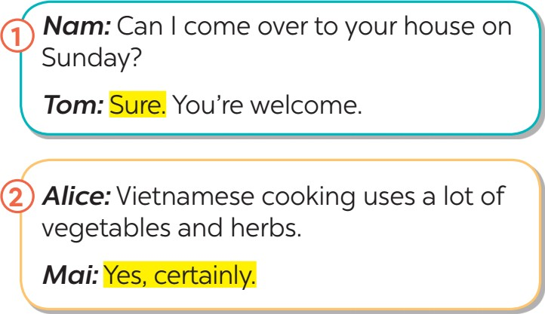
Procedure | - Play the recording for Ss to listen and read the two dialogues between Tom and Nam, Alice and Mai at the same time. Ask Ss to pay attention to the questions and answers.  - Have Ss practise the dialogues in pairs. Call on some pairs to practise the dialogues in front of the class.
Outcome | - Students know how to use the structures to express certainty.
Activity 3:Make similar conversations to express certainty in the following situations. (5 minutes)
Goal | The activity aims at making similar conversation to express certainly.
Input | Form Examples  How to express certainty - Sure. - Yes, certainly.
Procedure | - Ask Ss to work in pairs to make similar dialogues with the given cues.  - Move around to observe and provide help. Call on some pairs to practise in front of the class.  - Comment on their performance.
Outcome | Suggested answers:  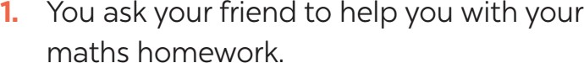  A: Can you help me with my maths homework?  B: Yes, certainly. / Yes, sure.  A: Vietnamese people love seafood.  B: Yes, certainly. / Yes, sure.
Activity 4: Do the quiz to find the correct answer about the cuisines of difference countries.
(3 minutes)
Goal | - The activity aims at helping Ss know about the cuisine of different countries around the world.
Input | Teacher elicits some cuisines of difference countries around the world.  - Vietnam: Bun Cha and Banh Xeo  - Italy: Neapolitan Pizza  - Australia: Meat Pie  - England: Fish and Chips and Sunday Roast
Procedure | - Ss work in pairs and do the quiz.  - Give explanations if necessary.  - Check their answers as a class.
Outcome | Answer key:  - B  - A  - C  - A  - B
Activity 5: Read and discuss the questions (10 minutes)
Goal | - The activity aims at talking about their option and give reasons about food.
Input | 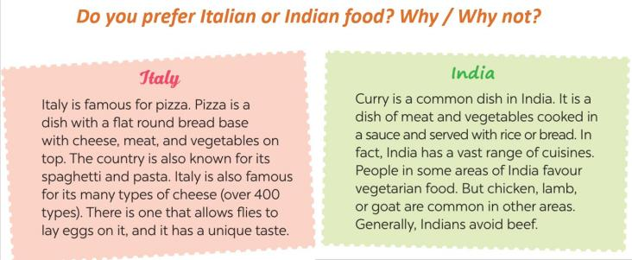
Procedure | - Ss read the passages for a few minutes. Make sure they understand the main ideas, and explain if needed.  - Ss work in groups. Each gives their preference (Italian or Indian food), and gives reasons.  - T goes round the class to monitor. T corrects Ss’ mistakes only when it is really necessary.  - T calls on some Ss to perform the task in front of the class. T and other Ss listen and make comments.
Outcome | Students can talk about their opinion and give reasons; ask and answer questions about food.
Activity 6: Talk about the typical food in your area. (12 minutes)
Goal | - The activity aims at talking about the typical food.
Input | Teacher show example for Ss  A: What is the staple food in your area?  B: It’s rice.  C: Yes. We have rice with most of our meals.
Procedure | - Have Ss work in groups, taking turns to ask and answer.  - Let Ss think and give the answers.  - Encourage them to say what they know and what they think. Their opinions may differ.  - Call on some pairs to perform the task in front of the class. T and other Ss listen and make comments.
Outcome | - staple food: rice, corn, bread, …  - favourite food: pork, chicken, beef, fish, seafood, ...  - foods eaten on special occasions: banh chung, moon cakes, sticky rice,...
Wrap-up: ( 5 minutes)
Ask Ss to summarize what they have learnt in the lesson. Have Ss look at the objectives written on the board at the beginning of the lesson and tick the objectives they have learnt.

Date of preparing: 11/12/2024 Period: 45
Date of teaching: 13/12/2024 Week: 15
TEACHING PLAN
Lesson 5: UNIT 6: LIFESTYLES- SKILLS 1
Timing: 1 period (45 minutes)
I. Objectives
1.Knowledge: By the end of this unit students can:
a. Skills:
Reading: scan for specific information read about Alaska
Speaking: talk about how people in their area maintain traditional lifestyles
b. Language:
Vocabulary: use some vocabulary about lifestyles
Grammar: use clues to ask and answer about what people in some places do to maintain their traditional lifestyle
2. Competence
Students can tell everyone about their lifestyles
3. Attitude
Students can develop communication skills and creativity, be collaborative and supportive in pair work and teamwork and actively join in class activities
II. Teaching aids (& materials)
Student book TA 8, p.p.t file, pictures of different lifestyles
III. Procedure
Activity 1: Setting the scene (3 minutes)
Goal | The activity aims at creating an active atmosphere in the class before the lesson and leading into the new unit
Input | Discuss the pictures
Procedure | - Ask Ss to work in pairs discussing what they can see in the picture.  - Ask some Ss to say their answers in front of the class. Encourage Ss to talk as much as possible. It is not important whether they give the right answers or not; it is important that they can speak in English.  - Introduce the objectives of the lesson.
Outcome | 1. Ss have an exciting atmosphere to start the lesson  2. Expected answers:  + Alaska: a state of the US (49th)  + location: northwest of North America  + population: over 700,000  + climate: oceanic climate, very cold  + native people: Alaskan Natives  + languages: English 86.3%, Alaska native language ....
Activity 2: Teaching new words (5 minutes)
Goal | The activity aims at providing students with vocabulary and helping students well-prepared for the reading and speaking tasks.
Input | Form Pronunciation Vietnamese equivalent  1. maintain (v) /meɪnˈteɪn/ duy trì, gìn giữ  2. experience (v) /ɪkˈspɪəriəns/ trải nghiệm  3. style (n) /staɪl/ phong cách  4. musher (n) /ˈmʌʃə/ người điều khiển xe trượt tuyết chó kéo
Procedure | – follow steps of teaching new vocabulary  - use “RUB OUT AND REMEMBER”to check vocabulary
Outcome | 1. Ss have certain vocabulary for the reading and speaking tasks.  2. four new words
Activity 3 : Activating Ss' knowledge of the topic (2 minutes)
Goal | The activity aims at activating Ss' knowledge of the topic of the reading text.
Input | Read the text and check your answers in the Warm-up part.
Procedure | - T have Ss read the text carefully and ask them to find information in the text check their answers in the Warm-up part.  - T helps Ss to confirm correct information about Alaska.
Outcome | - Ss express their thought about the topic  Key:  Alaska: a state of the US (49th)  location: northwest of North America  population: over 700,000  climate: oceanic climate, very cold  native people: Alaskan Natives  languages: English 86.3%, Alaska native language ....
Activity 4: Reading ( 5 minutes)
Goal | The activity aims at helping Ss develop the skill of finding the main idea and  guessing the meaning of new words in context.
Input | Match the highlighted words in the text with their meanings.
Procedure | - Ask Ss to work individually to read the passage and find the highlighted words.  - Have Ss read aloud the highlighted words. Correct their pronunciation if needed.  - Have Ss match the highlighted words with their meaning in the table. Remind them to use the context to help them.  - Check the answers as a class.
Outcome | Key:  - d  - a  - c  - b

Activity 5 : Reading ( 10 minutes)
Goal | The activity aims at developing the skill of reading for specific  information (scanning).
Input | Read the text again and answer the questions.
Procedure | - Ask Ss to do the task individually. Tell them to read the passage two or three times, then read each question, pause to identify where it appears in the text, read that part carefully and give the correct answer.  - Ask Ss to work with a partner to discuss the answers.  - Explain the new words and clarify anything difficult. T may ask more questions to see if they understand the text fully.  - Call on some Ss to read the answers aloud before the class. Check their pronunciation and intonation.  - Check the answers as a class.
Outcome | Answer key:  - It is about 730,000 / 730 thousand.  - Various native groups have their own special styles of carving or weaving.  - We can find it in their villages.  - It is 1,510 km (long).  - Yes, it is.
Activity 6 : Preparing ideas ( 8 minutes)
Goal | The activity aims at preparing ideas to talk about what people in some places do to maintain their traditional lifestyle.
Input | Work in pairs. Look at the pictures and use the cues to talk about what people in some places do to maintain their traditional lifestyle.
Procedure | - Give Ss time to study the example, the pictures, and the phrases given.  - Then have Ss work in pairs.  - T goes round to monitor and give help when necessary.  Call on some pairs to perform the task in front of the class. T and other Ss listen and comment.
Outcome | 1. Ss master the ways to ask and answer about lifestyles  2. Suggested outcome:  A: What do people in Chau An Village do to maintain their traditional lifestyle?  B: They perform traditional dances. They also …
Activity 7 : Reporting ideas ( 7 minutes)
Goal | The activity aims at reporting their group’s answers about what people in some places do to maintain their traditional lifestyle.
Input | Work in pairs. Ask and answer about how people in your area maintain their traditional lifestyle. You can use the ideas in 4 and the reading text in 1.
Procedure | - - Allow some time for Ss to think about how people in their area maintain the traditional lifestyle.  - Have Ss work in pairs (or groups of 4 - 5).  - Ask them to use the ideas in Activity 4, and the vocabulary learnt in the unit.  - Give help when they have difficulty expressing their ideas.  Call on some pairs to talk in front of the class. T and other Ss listen and comment.
Outcome | - Ss master the ways to ask and answer about lifestyles  2. Expected answer:  I live in Bat Trang, which is a pottery village not far from Ha Noi centre. To maintain the traditional lifestyle, local people will make pottery and paint on the ceramic statues. Then they will sell those pottery products to tourists.
Wrap-up: ( 5 minutes)
- Ask Ss to summarise what they have learnt in the lesson.
- Have Ss look at the objectives written on the board at the beginning of the lesson and tick the
objectives they can do.

DUYỆT CỦA TỔ TRƯỞNG NGƯỜI SOẠN

Phạm Thị Tuyết Hoa Đỗ Thị Thu Hằng

