**Week: 4**

**Period: 10**

**Date of teaching: 24/9/2024**

**UNIT 2: HEALTHY LIVING-Lesson 2: A CLOSER LOOK 1 - LANGUAGE FOCUS 1,2**

**Timing: 1 period (45 minutes)**

**I. Objectives**

**1.Knowledge:** By the end of this unit students can:

**a.** Skills:

- *Main skill*

Speaking: pronounce the sounds /f/ and /v/ correctly in sentences

*- Sub- skill*:

Listening: listen for the sounds /f/ and /v/

**b.** Language:

Vocabulary: name some nouns about health problems

**2. Competence**

Students can pronounce the sounds /f/ and /v/ correctly in sentences and tell everyone about health problems and how to avoid them

**3. Attitude**

Students can develop communication skills and creativity, be collaborative and supportive in pair work and teamwork and actively join in class activities

**II. Teaching aids (& materials)**

Student book TA 7, p.p.t file, pictures of hobbies

**III. Procedure**

**Activity 1: Setting the scene (5 minutes)**

|  |  |
| --- | --- |
| **Goal** | The activity aims at creating an active atmosphere in the class before the lesson and leading into the new unit |
| **Input** | **GAME: FACE TO FACE:**  **Team A (Cats) Team B (Dogs)** |
| **Procedure** | - Teacher divides class into 2 teams: Cats and Dogs.  - Teacher asks students to think of words or phrases related to “Healthy activities” which they have learnt in the previous lesson or words they may know already.  - Ss have 3 minutes to think of the topic  - Students in each team turn by turn stand up and say 1 word or phrase related to the topic.  - In 90 seconds, the team has more right answers will be the winner, and the team repeat the word which is mentioned already or cannot give a word will be the loser. |
| **Outcome** | 1. Ss have an exciting atmosphere to start the lesson  2. Expected answers:  - Going cycling/ swimming - Walking  - Boating - Eating breakfast  - Doing yoga/ aerobics - Playing sports  - …. |

**Activity 2: Teaching vocabulary (5 minutes)**

|  |  |
| --- | --- |
| **Goal** | The activity aims at providing students with vocabulary and helping students well-prepared for the listening and reading tasks. |
| **Input** | 1. dim light (n.phr): ánh sáng lờ mờ  2. lip balm (n.phr.): son dưỡng môi  3. chapped lips (n.phr.): môi nứt nẻ  4. coloured vegetables (n.phr.): rau có màu sắc  5. red spots (n.phr.): đốm đỏ  6. skin condition (n.phr.): điều kiện da |
| **Procedure** | – follow steps of teaching new vocabulary  - use “WHAT AND WHERE” to check vocabulary |
| **Outcome** | 1. Ss have certain vocabulary for the listening and reading tasks.  2. six new words |

**Activity 3 : Presenting some health problems (10 minutes)**

|  |  |
| --- | --- |
| **Goal** | The activity aims at presenting some nouns to describe about health problems |
| **Input** | **Task 1: Match the phrases on the left with the correct pictures on the right.**  https://img.loigiaihay.com/picture/2022/0314/task1-acloserlook1-u2-ta7.png |
| **Procedure** | - Teacher asks students to work independently to do matching.  - Ss work individually.  - Teacher has students to check their work with their partner.  - Then, teacher call one student to do matching in front of the class and give correct answer. |
| **Outcome** | 1. Ss know some noun phrases to describe about health problems  2.Expected answer:  1. c 2. e 3. d 4. a 5. b |

**Activity 4 : Practising more on vocabulary ( 5 minutes)**

|  |  |
| --- | --- |
| **Goal** | The activity aims at helping student use the words/ phrases in specific contexts |
| **Input** | **Task 2. Complete the sentences with the correct words and phrases below**.   |  | | --- | | skin condition         soft drinks       coloured vegetables     sunburn           fit |   1. - Please name some __________.      - Carrots and tomatoes  2. _________ are not good for your health.  3. My parents go cycling every Sunday. It keeps them _________.  4. The weather may effect our ___________.  5. - How do we get ________?     - When we spend a long time in the sun without a hat or suncream. |
| **Procedure** | - Teacher asks students to read the words and phrases provided aloud and give them their meaning if necessary.  - Teacher asks Ss to work individually.  - Then, teacher calls some students to check and asks them to explain their answers.  - Teacher checks students ‘answers as a class. |
| **Outcome** | 1. Ss know more about healthy living  2. **Key**  1. coloured vegetables 2. Soft drinks  3. fit 4. skin condition 5. sunburn |

**Activity 5 : Discussing about how to give advice about healthy living ( 5 minutes)**

|  |  |
| --- | --- |
| **Goal** | The activity aims at helping students talk about their daily activities and decide if each activity is healthy or unhealthy. |
| **Input** | **Task 3**: **Work in pairs. Discuss and tick (✓) each activity in the tables as H (Healthy) or U (Unhealthy).** |
| **Procedure** | - First, teacher asks students to read all the sentences in the table and find out any words are new to them.  - Then, teacher has students work in group of 4 - 6 to discuss whether each activity is healthy or unhealthy.  - Ss work in groups.  - Finally, teacher calls out some group to give and explain their answers as a class.  - Teacher listens and correct their answers. |
| **Outcome** | 1. Ss know more about daily activities and decide if each activity is healthy or unhealthy.  2. **Key**  Healthy: 1, 3, 4 Unhealthy: 2, 5 |

**Activity 5 : Pronouncing the sounds ( 5 minutes)**

|  |  |
| --- | --- |
| **Goal** | The activity aims at helping Ss identify how to pronounce the sounds “f” and “v” and practise pronouncing these sounds in words. |
| **Input** | **PRONUNCIATION /f/ and /v/**  **Task 4: Listen and repeat. Pay attention to the sounds /f/ and /v/.** |
| **Procedure** | - Teacher writes on the board two words “***f***it” and “***v***egetables”.  - Then, teacher has students focus on the underlined letters “f” and “v”.  - Ss practice saying the word individually.  - Teacher calls some students to read aloud.  - Teacher corrects if necessary.  - After that, teacher says “In this lesson we are going to learn how to pronounce two sounds f and v”.  - Teacher asks Ss to watch Tiếng Anh 7 - Pronunciation video Unit 2  *(link YouTube)*  - Ss imitate and practice the two sounds together.  - Teacher explains if necessary. |
| **Outcome** | 1. Ss can identify how to pronounce the sounds /f/ , /v/  2**.** Expected answer:   |  |  | | --- | --- | | **/f/** | **/v/** | | **f**ood /**f**uːd/  break**f**ast /ˈbrek.**f**əst/  a**ff**ect  /əˈ**f**ekt/  **f**it /**f**ɪt/ | acti**v**ity  /ækˈtɪ**v**.ə.ti/  **v**itamin  /ˈ**v**ɪt.ə.mɪn/  a**v**oid /əˈ**v**ɔɪd/  acti**v**e /ˈæk.tɪ**v**/ | |

**Activity 6 : Interviewing ( 5 minutes)**

|  |  |
| --- | --- |
| **Goal** | The activity aims at helping Ss pronounce the sounds /f/ , /v/correctly in sentences. |
| **Input** | **Task: Listen and repeat, paying attention to the underlined words.**  1. Coloured vegetables are good food.  2. My favourite outdoor activity is cycling.  3. We need vitamin A for our eyes.  4. Being active helps keep you fit.  5. Jack never eats fish. |
| **Procedure** | - Teacher has students read the sentences and tell them to pay attention to the underlined words with sounds /f/ and /v/.  - Ss read and underline the words  - Teacher plays the recording for students to listen and repeat each sentence.  - Teacher corrects their pronunciation if necessary.  - Teacher calls on some students to read the sentences individually. |
| **Outcome** | 1. Ss pronounce the sounds /ə/ , /ɜ:/correctly in sentences.  2. Expected answer:  **1.** vegetables /ˈ**v**edʒ.tə.bəls/ food /**f**uːd/  **2.** favourite /ˈ**f**eɪ.vər.ɪt/ activity /ækˈtɪ**v**.ə.ti/  **3.** vitamin /ˈ**v**ɪt.ə.mɪn/ for /**f**ɔːr/  **4.** active /ˈæk.tɪ**v**/ fit /**f**ɪt/  **5.** never /ˈnev.ər/ fish /**f**ɪʃ/ |

**Wrap-up: ( 5 minutes)**

- Teacher asks students to talk about what they have learnt in the lesson.

- Find 5 more words with the sound /f/ and 5 more words with the sound /v/. Write them down and practice pronouncing the words.

- Ask ss to do Language focus 1 and 2 at home.

- Prepare A Closer Look 2 on pae 21.

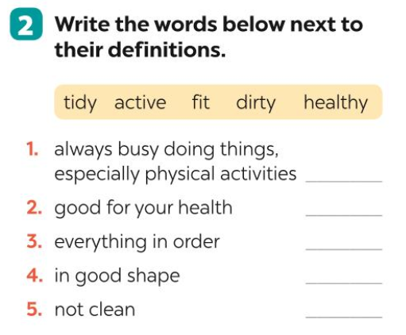

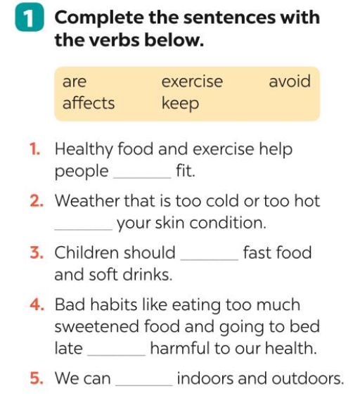

**Week: 4**

**Period: 11**

**Date of teaching: 24/9/2024**

**UNIT 2: HEALTHY LIVING – Lesson 3-A CLOSER LOOK 2 + LANGUAGE FOCUS 3,4**

**Timing: 1 period (45 minutes)**

**I. Objectives**

**1. Knowledge:** By the end of this unit students can be able to use the simple sentences correctly

**2. Competence**

Students can use the simple sentences to talk about health problems and giving advice on how to stay healthy.

**3. Attitude**

Students can develop communication skills and creativity, be collaborative and supportive in pair work and teamwork and actively join in class activities

**II. Teaching aids (& materials)**

Student book TA 7, ppt file, pictures of hobbies

**III. Procedure**

**Activity 1: Setting the scene (10 minutes)**

|  |  |
| --- | --- |
| **Goal** | The activity aims at creating an active atmosphere in the class before the lesson and leading into the new unit |
| **Input** | **GAME:JUMBLED SENTENCES**  1. books / I / science / read /.  2. games / children / love / outdoor /.  3. their / every day / they / clean / house /.  4. night / watched / I / T.V / last /.  5. learn / words / every day / You / should / the / new /. |
| **Procedure** | - In groups, Ss discuss to rearrange the words to make meaningful and completed sentences.  - The group which can finish all the sentences first and has all correct answers will be the winner.  - Teacher checks and corrects Ss’ answer.  - Teacher says: “This lesson today is going to tell you about “simple sentences”.  **SIMPLE SENTENCES**  - Teacher draws students’ attention to the sentences in the answers from the Warm-up and writes 1 more example, then underlines the main parts of each sentence.  EX: It rained.  S V  I read science books.  S V O  I watched T.V last night.  S V O A  - Ss look at the board and listen to the teacher’s questions to identify each part of a sentences.  - Ss answer the teacher’s questions, then read *REMEMBER* box in Ss’ book.  - Teacher tells Ss that ***a simple sentence has only one subject and one verb, some simple sentences also have an object, some simple sentences also have an adverb***. |
| **Outcome** | 1. Ss have an exciting atmosphere to start the lesson  2. Expected answers:  1. I read science books. 2. Children love outdoor games.  3. They clean their house every day.  4. I watched T.V last night.  5. You should learn the new words every day. |

**Activity 2 : Identifying and remembering the uses simple sentences (5 minutes)**

|  |  |
| --- | --- |
| **Goal** | The activity aims at helping ss identify and remember the uses of the simple sentences. |
| **Input** | **Task 1: Tick (✓) the simple sentences.**  1. The Japanese eat a lot of tofu.  2. She drinks lemonade every morning.  3. I don’t eat fast food, and I don’t drink soft drinks.  4. I am fit.  5. I like fish, but my sister likes meat. |
| **Procedure** | - Teacher asks students to do the exercise individually and then compare their answers with a classmate.  - Ss do the task individually.  - Some Ss explain their choices.  - Teacher confirms the correct answers. |
| **Outcome** | 1. Ss identify and remember the uses of the simple sentences.  2. Expected answer: Simple sentences: 1, 2, 4 |

**Activity 3 : Practising making the simple sentences (5 minutes)**

|  |  |
| --- | --- |
| **Goal** | The activity aims athelping Ss practise making the simple sentences |
| **Input** | **Task 2: Write S if the subject is missing from the sentence and V if the verb is.**  1. Vegetarians a lot of vegetables and fruit.  2. Causes red spots on the face.  3. On Saturday morning, my brother two hours of exercising at the sports center.  4. In the past, had a healthier diet.  5. At the moment, we our surroundings. |
| **Procedure** | - Teacher has students do this exercise individually by reading each sentence carefully to look for the two main parts.  - Ss do the task individually.  - Ss give and explain their answers.  - Teacher confirms the correct answers. |
| **Outcome** | 1. Ss can use recognize the simple sentences.  2. Key: |

**Activity 4 : Practising more with the simple sentences ( 5 minutes)**

|  |  |
| --- | --- |
| **Goal** | The activity aims at giving further practice with the simple sentences |
| **Input** | **Task 3. Rearrange the words and phrases to make simple sentences.**  1. soft drinks / never / my sister / drinks /.  2. affects / acne / 80% of young people /.  3. has / he / for breakfast / bread and eggs /.  4. don’t eat / we / much fast food /.  5. a lot of vitamins / fruit and vegetables / have /. |
| **Procedure** | - Teacher asks Ss to work in pairs.  - Ss work in pairs to do the task.  - Teacher calls on Ss to read aloud the complete sentences.  - Teacher confirms the correct answers. |
| **Outcome** | 1. Ss master the ways how to use the present simple correctly  2. **- Key**  1. My sister never drinks soft drinks.  2. Acne aﬀects 80% of young people.  3. He has bread and eggs for breakfast.  4. We don’t eat much fast food.  5. Fruit and vegetables have a lot of vitamins. |

**Activity 5 : Practising more with the simple sentences ( 5 minutes)**

|  |  |
| --- | --- |
| **Goal** | The activity aims at helping Ss do further practice with the simple sentences. |
| **Input** | **Task 4. Write complete sentences from the prompts. You may have to change the words or add some.**  1. tofu / be / healthy.  2. many Vietnamese / drink / green tea.  3. she / not / use / suncream.  4. father / not / exercise / every morning.  5. most children / have / chapped  lips and  skin / winter. |
| **Procedure** | - Teacher asks Ss to look at the prompts of each sentence and decide the two main parts of the sentence.  - Ss do the task individually.  - Call on some students to read out their answers.  - Teacher confirms the correct answers.  - Choose some typical errors and correct as a whole class without nominating the students’ names. |
| **Outcome** | 1. Ss master the ways how to use the present simple correctly  2**.** Expected answer:  1. Tofu is healthy.  2. Many Vietnamese drink green tea.  3. She does not use suncream.  4. My father does not exercise every morning.  5. Most children have chapped lips and skin in winter. |

**Activity 6 : Writing the simple sentences ( 10 minutes)**

|  |  |
| --- | --- |
| **Goal** | The activity aims at helping Ss practicing writing simple sentences. |
| **Input** | **Task 5. Work in pairs. Discuss and write a simple sentence from the two given sentences.**  **Example:** Many people are running.  Many people are exercising.  =>**Many people are running and exercising.**  **1.** We avoid sweetened food. We avoid soft drinks.  => We avoid ______________________________ .  **2.** My dad loves outdoor activities. I love outdoor activities.  => My _________________________________ love outdoor activities.  **3.** You should wear a hat. You should wear suncream.  => You should wear _____________________________.  **4.** My mother read the health tips. My mother downloaded the health tip*)*  => My mother ____________________________________________. |
| **Procedure** | - Teacher asks Ss to work in pairs to read the two separate sentences, discuss and determine the two main parts for the new sentence.  - Ss work in pairs.  - Call on some Ss to write the sentences on the board.  - Teacher corrects the answers.  - Choose some typical errors and correct as a whole class without nominating the students’ names. |
| **Outcome** | 1. Ss master the ways how to make sentences with the present simple correctly  2. Expected answer:  1. We avoid sweetened food and soft drinks.  2. My dad and I love outdoor activities.  3. You should wear a hat and suncream.  4. My mother read and downloaded the health tips. |

**Wrap-up: ( 5 minutes)**

- Ask Ss to summarize what they have learnt in the lesson.

- Have Ss look at the objectives written on the board at the beginning of the lesson and tick the

objectives they can do.

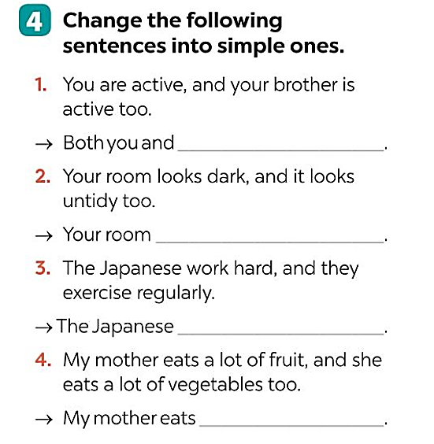- Ask ss to do Language focus 3 and 4 at home

- Prepare Communication on page 22.

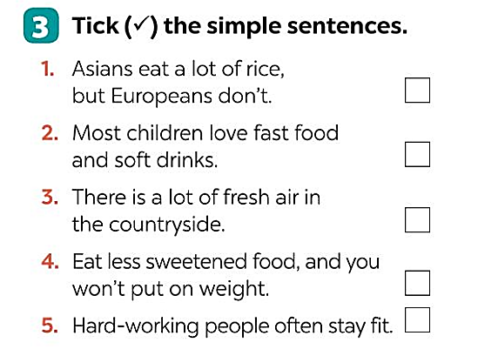

**Week: 4**

**Period: 12**

**Date of teaching: 27/9/2024**

**UNIT 2: HEALTHY LIVING- Lesson 4: COMMUNICATION**

**Timing: 1 period (45 minutes)**

**I. Objectives**

**1.Knowledge:** By the end of this unit students can:

**a.** Skills:

- *Main skill*

Speaking: tell everyone about giving tips for health problems

*- Sub- skill*:

Listening: listen for specific information about giving tips for health problems

Reading: read for specific information about tips for a healthy life

**b.** Language:

Vocabulary: use some vocabulary about health problems and tips for a healthy life

Grammar: use the simple sentences

**2. Competence**

Students can tell everyone about giving tips for health problems and tips for a healthy life and outline some vocabulary and grammar items related to the topic

**3. Attitude**

Students can develop communication skills and creativity, be collaborative and supportive in pair work and teamwork and actively join in class activities

**II. Teaching aids (& materials)**

Student book TA 7, ppt file, pictures of hobbies

**III. Procedure**

**Activity 1: Setting the scene (5 minutes)**

|  |  |
| --- | --- |
| **Goal** | The activity aims at creating an active atmosphere in the class before the lesson and leading into the new unit |
| **Input** | **GAME: BRAINSTORMING** |
| **Procedure** | - Teacher divides class into 2 teams and asks them to think of “health problems”.  - Ss have 1 min to think of the words related to the topic or they can discuss with their partners.  - Each member from each team turn by turn run to the board and write one word.  - Teacher corrects their answers.  - The team which has more correct words will be the winner  - Teacher leads students into the lesson by telling what they are going to learn: “We are going to learn how to give tips for health problems”. |
| **Outcome** | 1. Ss have an exciting atmosphere to start the lesson  2. Expected answers:  Asthma, a backache, a broken leg, a cold, a cough, an earache, a headache, a sore throat, a toothache, sunburn, etc. |

**Activity 2 : Introducing ways of giving tips for health problems (5 minutes)**

|  |  |
| --- | --- |
| **Goal** | The activity aims at introducing ways of giving tips for health problems |
| **Input** | **Task 1. Listen and read the conversation. Pay attention to the highlighted parts.**  **Girl:** My eyes are tired.  **Boy:** You can use eyedrops.  **Girl:** Yes.  **Boy:** And you shouldn't read in dim light.  **Girl:** Thank you. |
| **Procedure** | - Teacher plays the record for SS to listen and read the conversation about health problem.  - Ss listen and practice saying with their partners.  - Teacher calls some pairs to read aloud.  - Teacher corrects pronunciation if necessary­.  - Teacher asks Ss to pay attention to the highlighted parts and asks them some questions to elicit the new structure:  *- What do these sentences mean?*  *- When do we use these sentences?*  *- …*  - Ss answer teacher’s questions to find out new structure to give tips for health problems.  - Some students give the new structure to the teacher.  - Teacher corrects and writes on the board: |
| **Outcome** | 1. Ss identify and remember the uses of the present simple to talk about likes and dislikes in English  2. Expected answer**:**  **Structure: to give advice:**  - You should/ shouldn’t …  - You can … |

**Activity 3 : Practising talking about ways of giving tips for health problems (5 minutes)**

|  |  |
| --- | --- |
| **Goal** | The activity aims athelping Ss practise talking about ways of giving tips for health problems |
| **Input** | **Task 2. Make similar conversations for the health problems below.**  1. I’m tired.  2. I have acne.  3. My hands are chapped. |
| **Procedure** | -Teacher has Ss look at the situation in Ex 2 to make similar dialogue:  - Ss work in pairs to make similar dialogue.  - Teacher calls some pairs to present it in front of the class.  - Teacher gives feedback and some comments. |
| **Outcome** | 1. Ss can talk about likes and dislikes.  2. Key:  ***1.*** *A:* ***I am tired****.*  *B: You can drink some milk.*  *A: Yes.*  *B: And you should have a nap.*  *A: Thank you.*  **2. I have acne.**  **A:** I have acne.  **B:** You should wash your face.  **A:** Yes.  **B:** You shouldn’t touch your face.  **3.** **My hands are chapped.**  **A:** My hands are chapped.  **B:** You can use hand cream.  **A:** Yes.  **B:** You shouldn’t use chemical soaps. |

**Activity 4 : Practicing more on giving tips for a healthy life (5 minutes)**

|  |  |
| --- | --- |
| **Goal** | The activity aims at providing practice reading about tips for a healthy life. |
| **Input** | **Tips for a healthy life**  **Task 3. Read the passage and choose the correct title for it.**  A. How to live long  B. What food to eat  The Japanese live long lives. The main reason is their diet. They eat a lot of fish and vegetables. They cook fish with a little cooking oil. They also eat a lot of tofu, a product of soybeans. Tofu has vegetable protein and vitamin B. It doesn’t have any fat. The Japanese work hard and do a lot of outdoor activities too. This helps them keep fit. |
| **Procedure** | - Teacher asks Ss to read the passage independently and choose the correct answer of the main idea.  - Ss so the task individually.  - Teacher calls some Ss to give their answer and explain it.  - Teacher confirms the correct answers. |
| **Outcome** | 1. Ss master the ways to talk about their hobbies  2. – Key: **A** |

**Activity 5 : Discussing about the tips which help the Japanese live long lives ( 10 minutes)**

|  |  |
| --- | --- |
| **Goal** | The activity aims at helping Ss discuss about the tips which help the Japanese live long lives. |
| **Input** | **Task 4. Work in pairs. Discuss and make a list of the tips which help the Japanese live long lives. Present it to the class.** |
| **Procedure** | - Teacher has students work in groups to discuss and takes notes of the tips for a long life that they find in the text.  - Ss work in groups.  - 2-3 groups share their lists.  - Teacher confirms and corrects if necessary­. |
| **Outcome** | 1. Ss master the ways to talk about their hobbies  2**.** Expected answer:  (1) They eat a lot of fish and vegetable.  (2) They cook fish with little cooking oil.  (3) They also eat a lot of tofu.  (4) The Japanese work hard and do a lot of outdoor activities. |

**Activity 6 : Discussing about the tips which help the Vietnamese can do to live longer. (10minutes)**

|  |  |
| --- | --- |
| **Goal** | The activity aims at helping SS discuss about the tips which help the Vietnamese can do to live longer. |
| **Input** | Task 5. Work in groups. Discuss and make a list of the tips that the Vietnamese can do to live longer. Present it to the class. Does the class agree with you? |
| **Procedure** | - Teacher asks students to work in groups of 4- 5.  - Ss work in group of 4- 5 to discuss and come up with some tips for how the Vietnamese can live longer.  - Some groups share ideas with the whole class and other groups listen and add more their ideas.  - Teacher listens and corrects if necessary­. |
| **Outcome** | 1. Ss master the ways how to compare answers and giving a presentation about hobbies.  2. Expected answer:  1. avoid overeating  2. do more outdoor activities.  3. drink enough water  4. sleep before 10 p.m  5. eat more nuts.  6. do more exercises.  7. … |

**Wrap-up: ( 5 minutes)**

- Ask Ss to summarise what they have learnt in the lesson. Have Ss look at the objectives written on the board at the beginning of the lesson and tick the objectives they can do.

- Prepare Skills 1 on page 23.

**DUYỆT CỦA TỔ TRƯỞNG NGƯỜI SOẠN**

 

Phạm Thị Tuyết Hoa Đỗ Thị Thu Hằng