Week: 16
Period: 46
Date of teaching: 17/12/2024

UNIT 6: A VISIT TO A SCHOOL
Lesson 6: SKILLS 2
Timing: 1 period (45 minutes)
I. Objectives
1. Knowledge: By the end of this unit students can:
a. Skills:
- Main skills
Listening: listen for general and specific information about school activities.
Writing: write a paragraph about outdoor activities at one’s school.
- Sub skill:
Reading: read the questions and find the key words.
b. Language:
Vocabulary: use some vocabulary about school activities.
Grammar: use the present simple tense to write a paragraph about school activities.
2. Competence
Students can write a paragraph about some activities in their school.
3. Attitude
Students can develop communication skills and creativity, be collaborative and supportive in pair work and teamwork and actively join in class activities
II. Teaching aids (& materials)
Student book TA 7, ppt file
III. Procedure
Activity 1: Setting the scene (5 minutes)
Goal | The activity aims at creating an active atmosphere in the class before the lesson and leading into the new unit
Input | Game: The hidden word
Procedure | - T divides the class into 2 teams and asks members of each team to look at the screen and answer the questions.  - The team which has more points or can guess the hidden word first will be the winner.  - Ss listen and follow teacher’s instructions.  - Ss play in teams and discuss before giving the answers.  - T confirms the answers and gives feedback.  1. What is this?  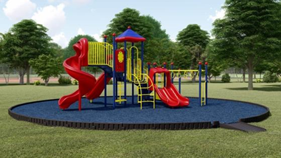  _ _ _ _ _ _ _ _ _ _  2. My favourite _ _ _ _ _ _ _ is maths.  3. Mi and Phong are members of Go Green _ _ _ _.  4. Quoc Hoc - Hue was _ _ _ _ _ _ _ in 1986.  5. The school year usually begins _ _ September 5th every year.
Outcome | 1. Ss have an exciting atmosphere to start the lesson  Answer key:  1. PLAYGROUND  2. SUBJECT  3. CLUB  4. FOUNDED  5. ON  Hidden word: O U T D O O R
Activity 2: Activating Ss' knowledge of the topic (5 minutes)
Goal | The activity aims at reminding students with vocabulary and helping students well-prepared for the listening and writing tasks.
Input | 1. Work in pairs. Look at the pictures and discuss the following questions. (Ex 1, p.67)  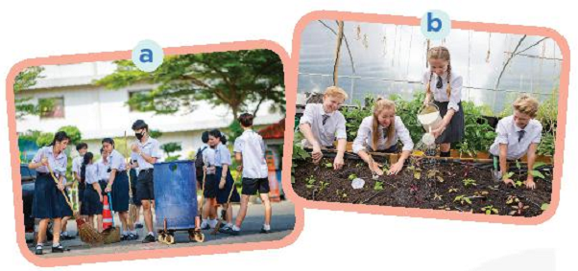  1. What outdoor activities do they take part in?  2. Why do they do these activities?
Procedure | - T asks Ss to look at the pictures and think about the outdoor activities they do (e.g. clean the streets in picture a, grow vegetables in picture b) and why they do these activities (e.g. to clean the environment, …)  - Ss quickly discuss with a partner.  - T asks some pairs to act out the dialogue in front of the class.  - T gives feedback.
Outcome | 1. Ss have some general imformation about listening.  Answer key:  1. They are collecting the garbage and planting trees.  2. Because they want to clean the environment.
Activity 3: Listening for general information (5 minutes)
Goal | The activity aims at helping Ss develop listening skills for general information.
Input | 2. Listen to an interview between a reporter and two students. Circle the appropriate option (A, B, or C) to complete each sentence. (Ex 2, p.67)  1. Trang and Phong are talking about ______  A. school subjects B. school timetables C. outdoor activities  2. They are members of ______ club(s).  A. one B. two C. three  3. The Go Green Club cleans streets on ______  A. Saturday afternoons B. Saturday mornings C. Sunday afternoons  4. They grow in the school garden.  A. vegetables B. flowers C. trees
Procedure | - T asks Ss to read the instructions and identify how to do the task, then has Ss read the questions and guess the option that can be used to complete the sentences.  - T plays the recording once or twice, if necessary.  - Ss listen and circle the answer.  - T allows Ss to peer check first.  - T confirms the answers and gives feedback.
Outcome | 1. Ss can recognise which information they need to use to answer the questions.  Answer key:  1. C  2. B  3. A  4. A  Audio script:  Reporter: Hello, Trang and Phong. Can you tell me something about your school outdoor activities?  Trang: Well. School is great. We are busy with our subjects, but we really enjoy the opportunities we have for outdoor activities.  Reporter: Great. What types of outdoor activities do you take part in?  Trang: I’m a member of a club called Go Green Club. And we do lots of activities.  Reporter: What activities, for example?  Trang: Well, our members clean streets on Saturday afternoons. We also encourage our classmates to recycle glass, cans, and paper.  Reporter: Wonderful! I’m sure your activities help us protect our environment. What about you, Phong? What outdoor activities do you do?  Phong: Well. I’m a member of the Green Garden Club. We grow vegetables in the school garden after school. Our school canteen uses the vegetables for our lunches.  Reporter: Sounds interesting. And …
Activity 4: Listening for specific information. (5 minutes)
Goal | The activity aims at helping Ss:  - understand what the interview is about.  - develop the skill of listening for specific information.
Input | 3. Listen to the interview again and answer the questions. ( Ex 3, p.67 )  1. What do Trang's club members encourage their classmates to do?  2. What does the reporter think about Trang's activities?  3. When and where do Phong's club members grow vegetables?
Procedure | - T asks Ss to read the questions and to focus on the key information and underline the keywords.  - T plays the audio again. Ask Ss to listen and give short answers.  - T lets Ss peer-check with a partner.  - T calls some Ss to give the answers to the class and correct the mistakes where necessary, encourages students to explain their answers, and shares some tips on finding the information.
Outcome | 1. Ss can hear the key word and answer the questions.  Answer key:  1. They encourage their classmates to recycle glass, cans, and paper.  2. The reporter thinks their activities protect the environment.  3. They grow vegetables in the school garden after school.
Activity 5: Brainstorming ideas for the writing (5 minutes)
Goal | The activity aims at helping Ss prepare ideas for their writing.
Input | 4. Work in pairs. Ask and answer questions about your school's outdoor activities. ( Ex 4, p.67 )  1. What outdoor activities do you take part in at school?  2. Which outdoor activity do you like the best?  3. Why do you like doing it?
Procedure | - T asks Ss to read the questions individually. Draw the attention to three pieces of information.  - Ss work in pairs, answer the questions and take notes.  - T goes around and helps if needed.  - Others comment and write them in their notebooks
Outcome | - Ss can get the ideas to write a paragraph.  Expected answer:  1. Outdoor activities I take part in at school: planting trees, pickup up rubbish, sorting the garbage,..  2. My favourite outdoor activity is visiting parks, fields, playgrounds, riverbanks, forests and different other natural places to enjoy the outdoors.  3. Because it is good for everyone and happy
Activity 6: Write a paragraph about an outdoor activity. (10 minutes)
Goal | The activity aims at helping Ss practice writing a paragraph about an outdoor activity at school.
Input | 5. Write a paragraph of about 70 words about an outdoor activity at your school. You can use the information in 4.
Procedure | T shows a model of a short paragraph about a school’s outdoor activity. Then recalls students’ knowledge on the structure of a paragraph.  - T tells Ss to write a paragraph about their school’s outdoor activities using the suggested ideas in Task 4. T gives Ss some time to arrange the work within the groups and give each group a A2-sized plain card with some colors.  - T allows Ss time to write a paragraph (about 70 words).  - T allows students to cross check first.  - T gives feedback.
Outcome | 1. Ss can write a paragraph about an outdoor activity at school.  Expected answer:  My school has a lot of outdoor activities, but the one I participate in the most is planting trees. It is the activity held weekly in our school garden. It is very interesting because I can meet a lof of students in other classes.

Wrap-up: [5 minutes]
- Ask Ss to summarise what they have learnt in the lesson.
- Have Ss look at the objectives written on the board at the beginning of the lesson and tick the
objectives they can do.
- Prepare Project.

*EVALUATION:
………………………………………………………………………………………………………………………………………………………………………………………………………………………………………………………………………………………………………………………………………………………………………………………………………………………………………………………………………………………………………………………………………………………………………………………………

Week: 16
Period: 47
Date of teaching: 17/12/2024
TEACHING PLAN
UNIT 6: A VISIT TO A SCHOOL
Lesson 7: LOOKING BACK + PROJECT
Timing: 1 period (45 minutes)
I. Objectives
1. Knowledge: By the end of this unit students can:
a. Skills:
Review the vocabulary and grammar of Unit 6
Apply what they have learnt (vocabulary and grammar) into practice through a project
b. Language:
Vocabulary: use some vocabulary about school activities and facilities
Grammar: use the preposition of time and preposition of place (at, in, on), When and Where
2. Competence
Students can remember the vocabulary and grammar of Unit 6
3. Attitude
Students can develop communication skills and creativity, be collaborative and supportive in pair work and teamwork and actively join in class activities
II. Teaching aids (& materials)
Student book TA 7 Global Success, ppt file
III. Procedure
Activity 1: Setting the scene (5 minutes)
Goal | The activity aims at revising the vocabulary related to the topic and lead in the next part of the lesson.  enhancing students’ skills of cooperating with teammates.
Input | BRAINSTORMING: SCHOOL FACILITIES
Procedure | - T divides the board, and divides the class into 2 teams.  - Members of each team take turns and write as many school facilities as possible in 2 minutes.  - Ss cross check their answers first.  - T confirms the answers and gives feedback. The group having more correct answers is the winner.
Outcome | School facility words:  - Classrooms  - Library  - Art Room  - Computer room  - Gym  - Playground  - School garden  - Laboratory  - Sport room  - School hall
Goal | The activity aims at revising the vocabulary related to the topic and lead in the next part of the lesson.  - To enhance students’ skills of cooperating with teammates.
Activity 2: Revising vocabulary (5 minutes)
Input | 1. Find the words and phrases from this unit that match these definitions. (Ex 1, p.68)  1. known by many people ______________  2. buildings, services, equipment, etc. at a school ______________  3. an exam taken to enter a school ______________  4. intelligent and / or talented students ______________  5. extra activities that students do at school ______________
Procedure | - T encourages Ss to complete the task individually.  - Ss do the task individually.  - Ss exchange their textbooks with their partners.  - T gives feedback as a class discussion.
Outcome | Ss can remember the vocabulary  Asnwer key:  1. well-known  2. facilities  3. entrance exam  4. gifted students  5. outdoor activities
Activity 3: Completing the sentences. (5 minutes)
Goal | The activity aims at helping Ss use the words / phrases in Task 1 to complete the sentences.
Input | 2. Complete the sentences with the words and phrases in 1. ( Ex 2, p.68)  1. The school is free for ________ who pass some exams.  2. The students in the school find ________ useful and enjoyable.  3. Chu Van An Lower Secondary School is famous for its intelligent students and modern ________  4. Students have to pass a difficult ________ to attend that school.  5. The most ________ teacher of Van Mieu - Quoc Tu Giam was Chu Van An.
Procedure | - T asks Ss to work in pairs, discussing what word / phrase can be used to complete each of the sentences.  - Ss work in pairs and discuss.  - T calls some Ss to read the complete sentences aloud.  - T gives feedback and comments.
Outcome | Answer key:  1. gifted students  2. outdoor activities  3. (school) facilities  4. an entrance exam  5. well-known
Activity 4: Revising prepositions of time and place. (10 minutes)
Goal | The activity aims at helping Ss revise prepositions of time and place.
Input | 3. Complete the sentences with appropriate prepositions of place or time. ( Ex 3, p.68)  1. The members of the club clean the school playground ________Saturday mornings.  2. The students have to sit for the final exam________ June.  3. Chu Van An Lower Secondary School is one of the most famous school ________Ha Noi.  4. The school canteen is ________the second floor.  5. Which subjects do you like to study ________school?
Procedure | - T has Ss read the instruction to know what they have to do. Draw their attention to the prepositions of time and place that they have learnt in the unit and which one can be used to complete the sentences.  - Ss complete the task individually.  - Ss exchange their textbooks with their partners.  - T gives feedback as a class discussion.
Outcome | Answer key:  1. on 2. in 3. in 4. on 5. at
Input | 4. Read the passage and fill in the gaps with prepositions of time or place. ( Ex 4, p.68)  Tom is a student (1) _______ a private school in the suburbs of Manchester. He lives with his parents (2) _______ a small house near his school. He usually studies at school (3) _______ the mornings. (4) _______ Monday and Thursday afternoons, he joins different outdoor activities with his schoolmates. He sings (5) _______ the Little Bees' Club on Tuesdays and Fridays. He goes to the cinema with his friends (6) _______ the weekend. He finds his studies and outdoor activities enjoyable.
Procedure | - T asks Ss to do individually first.  - Ss complete the task individually.  - T then asks them to check their answers with a partner before discussing the answers as a class.  - T reminds Ss to keep a record of their original answers so that they can use that information in their Now I can... statement.
Outcome | Answer key:  1. at  2. in  3. in  4. On  5. in  6. at
Activity 4: Project. (20 minutes)
Goal | The activity aims at helping Ss apply what they have learnt (vocabulary and grammar) into practice through a project.
Input | MY FAVOURITE SCHOOL
Procedure | - T has Ss work in groups as divided in Lesson 1 and gives instructions to students as follow:  1. Review about the information they have filled in the table at home:  Name of the school  Location  Subjects at school  School facilities  Outdoor activities  2. Discuss and finalize in groups.  3. Look at the table and tell the class about that school  - Ss do the project in groups.  - Ss vote for the best presentation.  -T gives feedback.
Outcome | Ss can give a presetation for their favourite school.

Wrap-up: ( 5 minutes)
- Ask Ss to summarize what they have learnt in the lesson.
- Have Ss look at the objectives written on the board at the beginning of the lesson and tick the
objectives they can do.
- Ask Ss to complete the self-assessment table.
- Identify any difficulties, weak areas, and provide further practice.
- Prepare for the next lesson: Unit 7 - Lesson 1: Getting started.

*EVALUATION:
………………………………………………………………………………………………………………………………………………………………………………………………………………………………………………………………………………………………………………………………………………………………………………………………………………………………………………………………………………………………………………………………………………………………………………………………

Week: 16
Period: 48
Date of teaching: 20/12/2024
TEACHING PLAN
REVIEW 2 - Lesson 1: Language
Timing: 1 period (45 minutes)
I. Objectives
1.Knowledge: By the end of this unit students will be able to revise:
- Vocabulary: words related to music and arts; food and drinks; to school facilities and school activities; pronouncing the sounds /ʃ/, /ʒ/, /ɒ/, /ɔ:/, /tʃ/ and /dʒ/ correctly;
- Grammar: the use of comparisons; some, a lot of, lots of; prepositions of time and place; how to - express preferences; ask and answer about prices;
2. Competence
Students can develop communication skills and cultural awareness, be collaborative and supportive in pair work and teamwork, and actively join in class activities
3. Attitude
Students can develop self-study skills
II. Teaching aids (& materials)
Student book TA 7, ppt file,
III. Procedure
Activity 1: Warming-up (4 minutes)
Goal | The activity aims at creating an active atmosphere in the class before the lesson and leading into the new unit
Input | 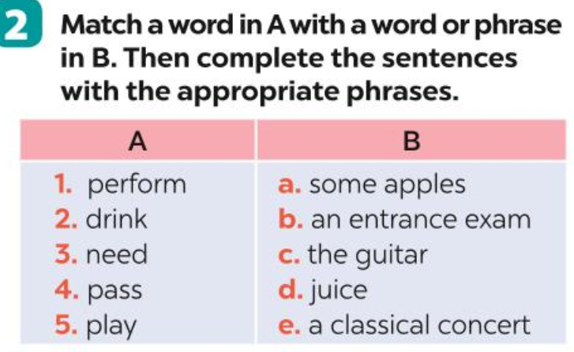
- Teacher asks ss to work in 4 teams to do the task.
- Ss follow the instructions, do the task & write their result on the board
- Teacher checks & corrects.
Outcome | 1. Ss have an exciting atmosphere to start the lesson  2. Expected answers: 1e, 2d, 3a, 4b, 5c.

Activity 2: Gap fill (6 minutes)
Goal | The activity aims at helping students review the phrases taught in Unit 4-6 and use them in different contexts.
Input | 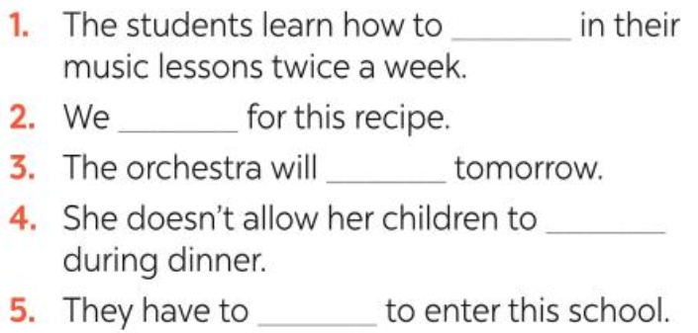
Procedure | – Teacher runs through sentences and asks ss to use the phrases in activity 1 to complete the sentences.  -SS work individually to do the task.  - Teacher checks & corrects
Outcome | Expected answer: 1. play the guitar  2. need some apples  3. perform a classical concert  4. drink juice  5. pass an entrance exam

Activity 3 : Odd one out (7 minutes)
Goal | The activity aims at helping students review the pronunciation of the sounds learnt in Units 4 - 6.
Input | 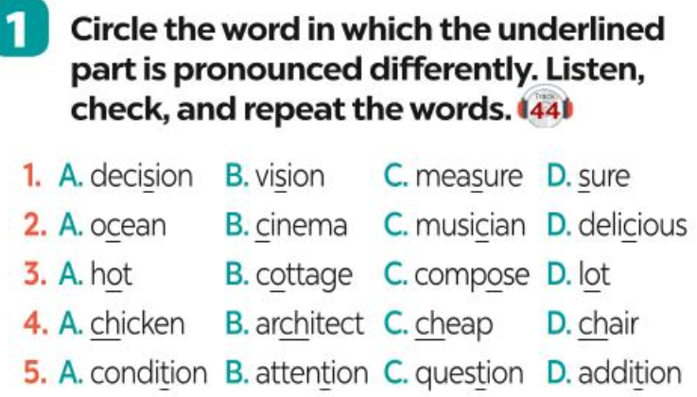
Procedure | - Teacher writes the sounds /ʃ/ and /ʒ/, /ɒ/ and /ɔ:/, /tʃ/ and /dʒ/on the board.  - Teacher writes one word containing the sound below each of them.  - Teacher asks students to read the words aloud.  - SS do the task individually , then listen to the recording to check and repeat.  - Teacher checks students’ pronunciation and gives feedback.
Outcome | * Expected answer: 1. D, 2. B, 3. C 4. B 5. C

Activity 4 : Choosing the correct word. (7 minutes)
Goal | The activity aims at helping students identify the words through different context.
Input | 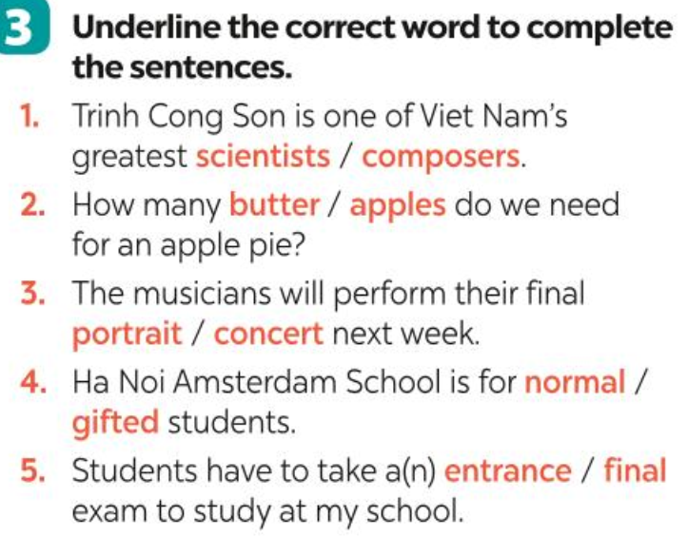
Procedure | -Teacher asks students to work individually to choose the correct words and complete the sentences.  - Students work individually to complete the task.  - Teacher allows students to share answers with a partner before discussing as a class.  -Teacher asks students to say the sentences aloud and makes sure they pronounce the words and phrases correctly. Teacher can ask for translation to check their understanding.
Outcome | * Expected answer: 1. composers 2. apples 3. concert 4. gifted 5. entrance

Activity 5 : Completing the passage ( 7 minutes)
Goal | The activity aims at reviewing grammar elements taught in Unit 5: How much, How many, some, a lot of.
Input | 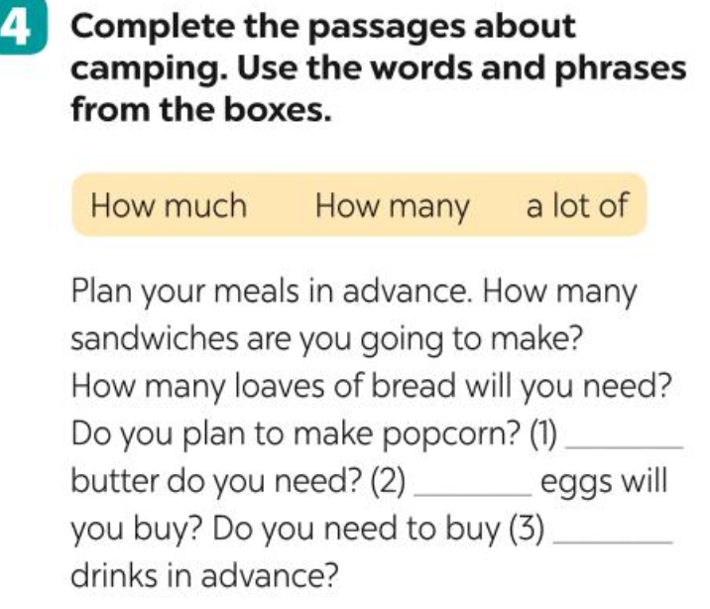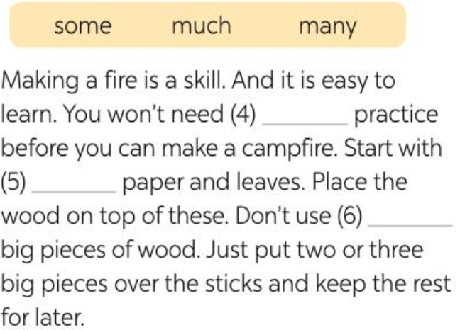
Procedure | - Teacher asks students to work independently to fill in the blanks with the correct words from the box.  - Students work individually to complete the task.  - Teacher allows students to share answers before discussing as a class.  - Teacher asks students to say the sentences aloud and makes sure they pronounce the words and phrases correctly. Teacher can ask for translation to check their understanding.
Outcome | * Expected answer: 1. How much 2. How many 3. a lot of  4. much 5. some 6. many
Activity 6 : Transformation sentences. ( 10 minutes)
Goal | The activity aims at reviewing grammar elements taught in Unit 4: more … than, different from, not as … as, the same as.
Input | 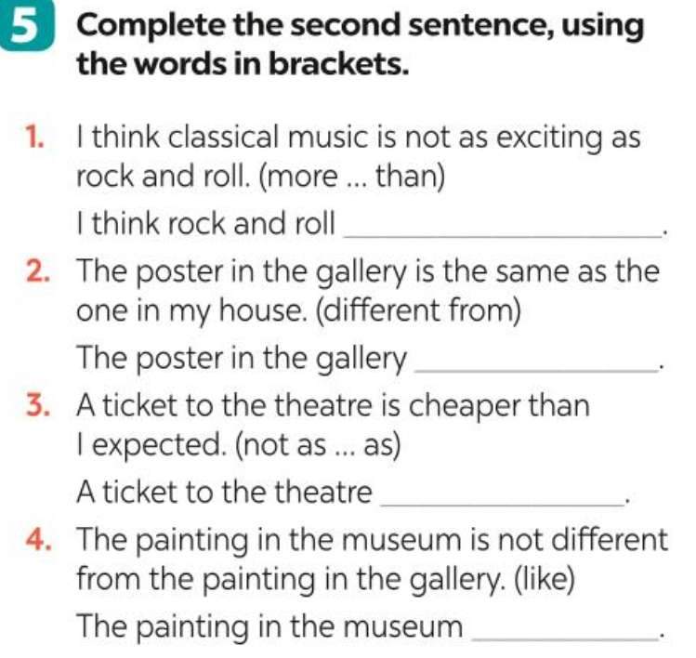
Procedure | - Teacher gives a brief revision of more … than, different from, not as … as, the same as then asks students to do the task individually.  - Students do the task individually.  - Teacher allows students to share answers before discussing as a class.  - Teacher asks students to say the sentences aloud and makes sure they pronounce the words and phrases correctly. Teacher can ask for translation to check their understanding.
Outcome | * Expected answer: 1. I think rock and roll is more exciting than classical music.  2. The poster in the gallery is not different from the one in my house.  3. A ticket to the theatre is not as expensive as I expected.  4. The painting in the museum is like the painting in the gallery.
Wrap-up: ( 4 minutes)
- Ask Ss to summarise what they have learnt in the lesson.
- Prepare for Skills lesson at page 71

*EVALUATION:
………………………………………………………………………………………………………………………………………………………………………………………………………………………………………………………………………………………………………………………………………………………………………………………………………………………………………………………………………………………………………………………………………………………………………………………………

DUYỆT CỦA TỔ TRƯỞNG NGƯỜI SOẠN

Phạm Thị Tuyết Hoa Đỗ Thị Thu Hằng

