**Week: 14**

**Period: 40**

**Date of teaching: 3/12/2024**

**UNIT 5: FOOD AND DRINK**

**Lesson 7: PROJECT**

**Timing: 1 period (45 minutes)**

**I. Objectives**

**1. Knowledge:** By the end of this unit students can:

**a.** Skills:

Speaking**:** talk about eating habits around the world

Write: write a paragraph about eating habits

**b.** Language:

Vocabulary: use some vocabulary about food and drink

Grammar: use the present simple tense to write a paragraph about eating habits

**2. Competence**

Students can write a paragraph about eating habits and present it in front of the class

**3. Attitude**

Students can develop communication skills and creativity, be collaborative and supportive in pair work and teamwork and actively join in class activities

**II. Teaching aids (& materials)**

Student book TA 7 Global Success, ppt file, pictures of food and drink

**III. Procedure**

**Project presentation (40 minutes)**

|  |  |
| --- | --- |
| **Goal** | The activity aims at presenting a project EATING HABITS AROUND THE WORLD |
| **Input** |  |
| **Procedure** | - Ask Ss to read the instructions. Make sure they understand what to do. Ask Ss to work in groups to do the project. Ss may draw their own pictures to decorate their poster or find suitable photos for it.  - Remember to have the ‘show and tell’ session and vote for the best poster.  - If time is limited, assign the project in earlier lessons such as in GETTING STARTED lesson. Make sure you guide them carefully and check their progress after each lesson. In the last lesson (LOOKING BACK), ask Ss to present their poster to the class. |
| **Outcome** | 1.  **Eating Habits in Viet Nam**    2. Hello everyone! My name’s ­­____­_. Today, I’m going to present my poster about eating habits in our country – Viet Nam. In our country, we have 3 main meals a day including breakfast, lunch, and dinner. At around 6.30 a.m., we usually have a light breakfast with a bowl of pho, rice noodle soup or bread. Some people eat a bowl of instant noodles and drink a cup of coffee before going to work. Lunch usually starts around 11.30 a.m. We usually eat rice with fish or meat and drink juice for lunch. Dinner usually starts at 6.00 p.m. with rice, lots of vegetables, some meat and fish. Then we usually have some fruit and some tea for dessert. Thank you for your listening. |

**Wrap-up: ( 5 minutes)**

- Ask Ss to summarize what they have learnt in the lesson.

- Have Ss look at the objectives written on the board at the beginning of the lesson and tick the

objectives they can do.

- Ask Ss to complete the self-assessment table.

- Identify any difficulties, weak areas, and provide further practice.

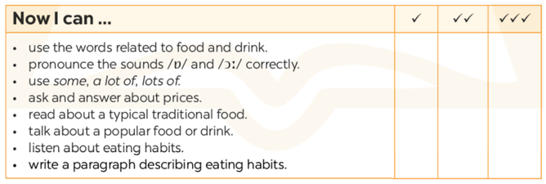

**\*EVALUATION:**

………………………………………………………………………………………………………………………………………………………………………………………………………………………………………………………………………………………………………………………………………………………………………………………………………………………………………………………………………………………………………………………………………………………………………………………………

**Week: 14**

**Period: 41**

**Date of teaching: 3/12/2024**

**UNIT 6: A VISIT TO A SCHOOL**

**Lesson 1: Getting started – A visit to Binh Minh Lower Secondary School**

**Timing: 1 period (45 minutes)**

**I. Objectives**

**1. Knowledge:** By the end of this unit students can:

**a.** Skills:

- *Main skill*

Speaking: tell everyone about someone’s timetable.

*- Sub- skills*:

Reading: read for specific information about Quoc Hoc - Hue

Listening: listen for specific information about school’s activities

Writing: outline some vocabulary and grammar items related to the topic

b. Language:

Vocabulary: name some vocabulary about school

Grammar: use the prepositions to talk about the time and the places

**2. Competence**

Students can tell everyone about their school and outline some vocabulary and grammar items related to the topic

**3. Attitude**

Students can develop communication skills and creativity, be collaborative and supportive in pair work and teamwork and actively join in class activities

**II. Teaching aids (& materials)**

Student book TA 7, ppt file, pictures of food and drink

**III. Procedure**

**Activity 1: Setting the scene (5 minutes)**

|  |  |
| --- | --- |
| **Goal** | The activity aims at creating an active atmosphere in the class before the lesson and leading into the new unit |
| **Input** | “A VISIT TO A SCHOOL” |
| **Procedure** | Before Ss open their books, T asks Ss **Have you ever visited another school? Like Tan Thanh Secondary School, Phong Hoa Secondary School,...** Summarize Ss' answers. Elicit the word ‘A Visit To A School’. Write the unit title on the board A VISIT TO A SCHOOL. Let Ss open their books and start the lesson. |
| **Outcome** | 1. Ss have an exciting atmosphere to start the lesson  2. Expected answers:  - Yes, I have.  - No, I haven’t. |

**Activity 2: Teaching new words (10 minutes)**

|  |  |
| --- | --- |
| **Goal** | The activity aims at providing students with vocabulary and helping students well-prepared for the listening and reading tasks. |
| **Input** | 1. Neighbourdhood (n) : vùng lân cận, xung quanh 2. Playground (n) : sân chơi 3. Computer room (n) : phòng máy tính 4. Gym (n) : phòng tập thể dục 5. School garden (n) : vườn trường 6. School library (n) : thư viện trường 7. Lower secondary school (n.phr.) : trường trung học cơ sở |
| **Procedure** | - Follow steps of teaching new vocabulary  - Use “Snap the board” to check vocabulary |
| **Outcome** | 1. Ss have certain vocabulary for the listening and reading tasks.  2. Six new words |

**Activity 3: Eliciting the conversation, vocabulary, sounds, and grammar points (5 minutes)**

|  |  |
| --- | --- |
| **Goal** | The activity aims at setting the context for the introductory conversation and introducing the topic of the unit, the vocabulary, the sounds, and the grammar points to be learnt. |
| **Input** | **1.Listen and read** *(Ex 1, p.60)* |
| **Procedure** | Ask Ss to look at the pictures and answer the questions:  1. Can you guess who they are?  2. What are they doing?  3. What are theytalking about?  - Introduce the two characters: Phong and Mi. Quickly write Ss’ answers on the board.  - Play the recording twice for Ss to listen and read along. Have Ss underline the words that are related to the topic of the unit while they are listening and reading.  - Invite some pairs of Ss to read the conversation aloud.  - Have Ss say the words in the text that they think are related to the topic Visiting a school. Quickly write the words on one part of the board. Comment on Ss' answers. |
| **Outcome** | 1. Ss understand the topic of the unit, the vocabulary, the sounds, and the grammar points to be learnt.  2.Expected answer**:**  - Phong and Mi (They are friends)  - Mi is preparing her things for the school’s visiting  - They’re talking about some activities and places in Binh Minh Lower Secondary School |

**Activity 4: Reading the dialogue (5 minutes)**

|  |  |
| --- | --- |
| **Goal** | The activity aims athelping Ss understand the conversation. |
| **Input** | **2. Read the conversation again and answer the questions by circling A, B, or C.** *(Ex 2, p.61)*  *1. What are they talking about?*  A. A visit to the computer room.  B. A visit to a school.  C. A visit to a school library.  *2. Who is going to visit the school?*  A. Mi and her teacher.  B. Mi and her classmate.  C. Mi, her teacher and her classmates.  *3. Where is the school?*  A. In the city.  B. In the countryside.  C. In Phong’s neighbourhood.  *4. When are they going?*  A. In the morning.  B. In the afternoon.  C. At noon. |
| **Procedure** | **-** First, ask Ss to read the questions and choose the correct answer without reading the conversation. Allow them to share their answers with a partner before discussing as a class. Ss may read the conversation again to confirm their answers before giving T the answers.  - Elicit the answers from Ss.  - Write the correct answers on the board. |
| **Outcome** | 1. Ss understand the conversation  2. ***Answer*** ***Key:*** 1. B 2. C 3. C 4. B |

**Activity 5: Revising vocabulary (5 minutes)**

|  |  |
| --- | --- |
| **Goal** | The activity aims atintroducing some vocabulary items related to the parts of the school. |
| **Input** | **3. Name these places, using the words and phrases from the box.** *(Ex 3, p.61)* |
| **Procedure** | - Have Ss quickly look at the phrases and the photos. Then ask Ss to label the phrases to the photos and compare their answers with their partners.  - Ask some Ss to read out their answers or write them on the board. With a weaker class, ask for translations of the words / phrases to make sure they understand them.  - Have some Ss practise saying the words and phrases again. |
| **Outcome** | ***Answer keys:***  1. gym  2. computer room  3. school garden  4. playground  5. school library |

**Activity 6: Reading for specific information (5 minutes)**

|  |  |
| --- | --- |
| **Goal** | The activity aims athelping Ss deeply understand school’s facilities. |
| **Input** | **4. Complete the sentences with the words and phrases in 3.** *(Ex 4, p.61)*  1. The school _______ is very small, so not many children can play in it.  2. We learn how to use the Internet in the ______ twice a week.  3. They have school meetings in the _______ when it rains.  4. There are a lot of books, magazines, and newspapers in the _____.  5. Our class usually waters the vegetables in the ________ on Friday afternoons. |
| **Procedure** | **-**Have Ss look at the statements in this activity. Ask them how to do it. Give them some strategies to do the exercise. (E.g. reading the statements, underlining the key words, deciding which word use for each sentence).  -Set a time limit for Ss to do the activities. When the time is up, have Ss share their answers in pairs. Invite some pairs to answer and confirm the correct ones. For strong classes, ask Ss to translate the sentences. |
| **Outcome** | ***Suggested keywords in the statements:*** 1. The school _______ is very small, so not many children can play in it.  2. We learn how to use the Internet in the ______ twice a week.  3. They have school meetings in the _______ when it rains.  4. There are a lot of books, magazines newspapers, and in the _____.  5. Our class usually waters the vegetables in the ________ on Friday afternoons.  ***Answer key:***  1. playground 2. computer room  3. gym 4. school library 5. school garden |

**Activity 7: Asking and answering (5 minutes)**

|  |  |
| --- | --- |
| **Goal** | The activity aims athelping Ss practise using When and Where to ask S.O’s timetable. |
| **Input** | **5. Work in pairs. Ask and answer questions about Nick’s timetable, using *when* and *where*.** *(Ex 5, p.61)*  Example:  A: When does Nick have Maths?  B: At 8 a.m on Monday, Tuesday, and Friday.  A: And where does he have it?  B: In his classroom, room 302. |
| **Procedure** | - Ask each student to think of the questions he / she may use to ask about Nick’s timetable.  - Demonstrate the activity to the class first. Ask a strong student to help you. Then ask Ss to work in pairs. T goes round to help weaker Ss. Call on some pairs to perform in front of the class. |
| **Outcome** | 1. Ss use when and where and information in the table to ask and answer about S.O’s timetable.  2. Expected answer:  A: When does he have Biology?  B: At 9 a.m on Thursday.  A: Where does he have it?  B: In the Science lab.  A: When does he have Information Technology?  B: At 2 p.m on Wednesday.  A: Where does he have it?  B: In the Computer room.  A: When does he have Physical Education?  B: At 3 p.m on Monday and Thursday.  A: Where does he have it?  B: In the School gym.  A: When does he have History?  B: At 3:30 p.m on Tuesday.  A: Where does he have it?  B: In the School labrary. |

**Wrap-up: (5 minutes)**

- Ask one or two Ss to tell the class what they have learnt. Ask Ss to say aloud some words / phrases they remember from the lesson. If there is a projector in the classroom, show the conversation; highlight the key words related to the topic.

- Prepare A Closer Look 1.

**Reference activities:**

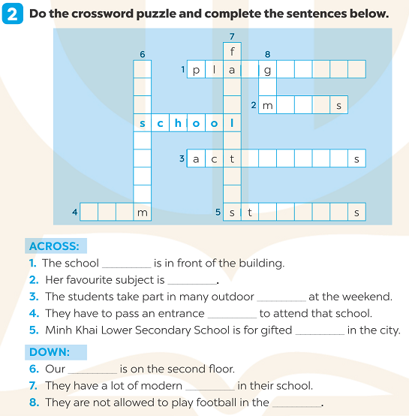

**\*EVALUATION:**

………………………………………………………………………………………………………………………………………………………………………………………………………………………………………………………………………………………………………………………………………………………………………………………………………………………………………………………………………………………………………………………………………………………………………………………………

**Week: 14**

**Period: 42**

**Date of teaching: 6/12/2024**

**UNIT 6: A VISIT TO A SCHOOL**

**Lesson 2: A CLOSER LOOK 1 + LANGUAGE FOCUS 1, 2**

**Timing: 1 period (45 minutes)**

**I. Objectives**

**1. Knowledge:** By the end of this unit students can:

**a.** Skills:

- *Main skill*

Speaking: pronounce the sounds /tʃ/ and /dʒ/correctly in sentences

*- Sub- skill*:

Listening: listen for the sounds /tʃ/ and /dʒ/

**b.** Language:

Vocabulary: words or phrases that use at school

Grammar: use questions and answers about the school activities.

**2. Competence**

Students can pronounce the sounds /tʃ/ and /dʒ/ correctly in sentences and tell everyone about school activities.

**3. Attitude**

Students can develop communication skills and creativity, be collaborative and supportive in pair work and teamwork and actively join in class activities**.**

**II. Teaching aids (& materials)**

Student book TA 7, p.p.t file.

**III. Procedure**

**Activity 1: Setting the scene (5 minutes)**

|  |  |
| --- | --- |
| **Goal** | The activity aims at creating an active atmosphere in the class before the lesson and leading into the new unit |
| **Input** | **Game: Whisper** |
| **Procedure** | Put Ss in small groups and explains the game rules.  T whispers some school facilities to one member from each team (*school playground, computer room, gym, school library, …*). Ss have to pass the secrets to the person next to him / her. The last student of each team says the word out loud. The team finishing more quickly and with more correct answers is the winner. |
| **Outcome** | 1. Ss have an exciting atmosphere to start the lesson  ***Expect words:***  *school playground*  *computer room*  *gym*  *school library*  *neighbourhood*  *lower seconary school*  *Maths*  *Physical Education* |

**Activity 2: Presenting school words / phrases (7 minutes)**

|  |  |
| --- | --- |
| **Goal** | The activity aims at revising and teaching some words / phrases often used with school. |
| **Input** | **1. Match the words in columns A and B to form phrases. Then say them aloud.**  *(Ex 1, p.62)* |
| **Procedure** | Have Ss quickly match the words in colums A and B to form phrases. Then ask Ss to check their answers with their partners.  T goes around and helps Ss. With weaker classes, ask for translations to check understanding. |
| **Outcome** | 1. Ss know how to make the words / phrases often used at school.  2.Expected answer:  ***Answer key:***  1. d       2. c         3. b         4. e          5. a |

**Activity 3: Practising the words/phrases. (6 minutes)**

|  |  |
| --- | --- |
| **Goal** | The activity aims atteaching Ss the words/phrases of school activities. |
| **Input** | 2. **Complete th sentences with the phrases in 1.** *(Ex 2, p. 62)*  1. Binh Minh Lower Secondary School is for _______ in the city.  2. Our _______ usually covers the first three units.  3. Students in my school take part in many______ during the school year.  4. Our school has a lot of modern _______.  5. In order to study at Quoc Hoc – Hue, you have to pass a(n) _______. |
| **Procedure** | First, check Ss' understanding of the meanings of the phrases in 1. With the phrases that Ss do not know, T may explain their meanings by using pictures, examples, or even translations.  Then, have Ss timing to complete the sentences. Ask Ss to check their answers and share them with their partners before T checks their answers with the whole class. |
| **Outcome** | 1. Ss can know how to use words/phrases of school activities.  ***Answer Key:***  1. gifted student  2. midterm test  3. outdoor activities  4. school facilities  5. entrance exam |

**Activity 4: Practising asking and answering about the school activities (7 minutes)**

|  |  |
| --- | --- |
| **Goal** | The activity aims athelping Ss practise asking and answering about the school activities using the words and phrases they have learnt. |
| **Input** | **3. Work in pairs. Answer the questions about your school.** *(Ex 3, p. 52)*  1. Can you name some gifted students in your school?  2. When does the first-term test take place?  3. Do you have to take an entrance examination to study at your school?  4. What kind of facilities does your school have?  5. What types of outdoor activities do you like to take part in? |
| **Procedure** | **-**Model this activity with a strong student.  -Ask Ss to work in pairs. Then, call on some pairs to practise in front of the class. |
| **Outcome** | 1. Ss practise asking and answering the questions.  2. Suggested answers:  1. Tran Thi Khanh Linh, Nguyen Do Yen Vy,…  2. In the first week  3. No, I don't  4. Dedicated Science Laboratories, Information and Communication Technology Labs  5. cyling, swimming, camping,.. |

**Activity 5: Pronouncing the sounds (5 minutes)**

|  |  |
| --- | --- |
| **Goal** | The activity aims athelping Ss identify how to pronounce the sounds /tʃ/ and /dʒ/ and practise pronouncing these sounds in words. |
| **Input** | **Pronunciation:** /tʃ/ and /dʒ/  **4. Listen and repeat the words. What letters can we use to make the /dʒ/** *(Ex 4, p.62)* |
| **Procedure** | - Model the sounds /tʃ/ and /dʒ/ first and let Ss see how the sounds are formed. Ask Ss to practise the sounds /tʃ/ and /dʒ/ together.  - Pays the recording and ask Ss to listen and repeat. Play the recording as many times as necessary. Ask Ss to give what letter we can use to make the sound /dʒ/. Ss compare their answers in pairs before T checks their answers with the whole class. |
| **Outcome** | 1. Ss can identify how to pronounce the sounds /tʃ/ and /dʒ/  ***Answer Key:*** Letters ‘J’ and “G” |

**Activity 6: Interviewing (10 minutes)**

|  |  |
| --- | --- |
| **Goal** | The activity aims athelping Ss practise pronouncing the sounds /tʃ/ and /dʒ/  correctly in context. |
| **Input** | **5.. Listen and repeat the chant. Pay attention to the sounds /tʃ/ – /dʒ/.** *(Ex 5, p.62)* |
| **Procedure** | **-** Have Ss quickly read the chant. Now play the recording for Ss to listen to the chant. Ask them to pay attention to the recording and SS can read along.  - Have Ss practise the chant in pairs. Invite some Ss to read the chant aloud. Comment on their pronunciation of the sounds. |
| **Outcome** | Ss pronounce the sounds /tʃ/ and /dʒ/correctly in chant. |

**Wrap-up: (5 minutes)**

- Ask Ss to summarise what they have learnt in the lesson.

- Have Ss look at the objectives written on the board at the beginning of the lesson and tick the objectives they can do.

- Ask Ss to prepare A Closer Look 2, page 63.

**Reference activities:**

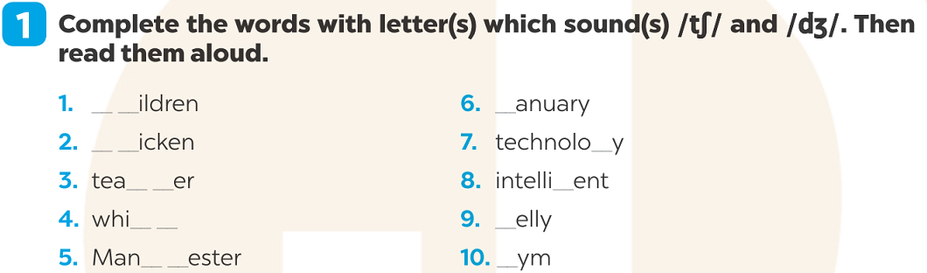

**\*EVALUATION:**

………………………………………………………………………………………………………………………………………………………………………………………………………………………………………………………………………………………………………………………………………………………………………………………………………………………………………………………………………………………………………………………………………………………………………………………………

**DUYỆT CỦA TỔ TRƯỞNG NGƯỜI SOẠN**

Phạm Thị Tuyết Hoa Đỗ Thị Thu Hằng