Week: 13
Period: 37
Date of teaching: 26/11/2024
UNIT 5: FOOD AND DRINK
Lesson 4: COMMUNICATION
Timing: 1 period (45 minutes)
I. Objectives
1. Knowledge: By the end of this unit students can:
a. Skills:
- Main skill
Speaking: tell everyone about the favourite food and drink in everyday life.
- Sub- skill:
Listening: listen for specific information about food and drink.
b.Language:
Vocabulary: use some vocabulary about food and drink
Grammar: Ask and answer about the prices of the food and drink on the menu.
2. Competence
Students can tell everyone about their classmate’s food and drink and outline some vocabulary and grammar items related to the topic
3. Attitude
Students can develop communication skills and creativity, be collaborative and supportive in pair work and teamwork and actively join in class activities
II. Teaching aids (& materials)
Student book TA 7, ppt file, pictures of food and drink
III. Procedure
Activity 1: Setting the scene (5 minutes)
Goal | The activity aims at creating an active atmosphere in the class before the lesson and leading into the new unit
Input | GAME: BRAINSTORMING  Food and drink
Procedure | - Teacher divides class into 2 teams and asks them to think of “food and drink”.  -Ss have 1 min to think of the words related to the topic or they can discuss with their partners.  - Each member from each team turn by turn run to the board and write one word.  - Teacher corrects their answers.  - The team which has more correct words will be the winner  - Teacher leads students into the lesson by telling what they are going to learn: “We are going to learn how to ask and answer about prices of food and drink”.
Outcome | 1. Ss have an exciting atmosphere to start the lesson  2. Expected answers:  Mineral water, milk, bread, pizza, green tea, noodles, pancake, etc.
Activity 2: Introducing ways of asking and answering about prices in English. (5 minutes)
Goal | The activity aims at introducing ways to ask and answer about prices in English.
Input | Asking and answering about prices  1. Listen and read the conversation. Pay attention to the questions and answers.  Mark: How much is a bottle of mineral water?  Mi: It's 5,000 dong.  Mark: And how much are two kilos of apples?  Mi: They're 50,000 dong.
Procedure | - Teacher gives Ss instructions.  - Ss listen carefully, watch closely and repeat as a whole class. They pay attention to the questions whenever Teacher pauses and corrects their mistakes.  - Ss work in pairs to repeat the conversation.  - Teacher shows the conversation on the screen to make sure they ask the correct questions.
Outcome | 1. Ss identify and remember the uses of “How much” to talk about the price in English  2. Expected answer:  Mark: How much is a bottle of mineral water?  Mi: It's 5,000 dong.  Mark: And how much are two kilos of apples?  Mi: They're 50,000 dong.
Activity 3: Practising asking and answering about the prices of the food and drink on the menu (10 minutes)
Goal | The activity aims at helping Ss practise asking and answering about the prices of the food and drink on the menu
Input | 2. Work in pairs. Take turns to ask and answer about the prices of the food and drink on the menu.  LY’S RESTAURANT  Breakfast menu  Food  bowl of beef noodle soup 30,000 dong  bowl of eel soup 35,000 dong  toast 20,000 dong  Drink  glass of milk 9,000 dong  bottle of miner water 8,000 dong  cup of green tea 5,000 dong  Example:  A: How much is a glass of milk?  B: It's 9,000 dong.
Procedure | -Teacher shows the menu on the screen, shows the sample of the conversation, pairs Ss and asks them to play the roles of a waiter and a customer to ask and answer about the prices of the food and drink on the menu.  - Ss practise for about 3 minutes.  -Ss work with another partner and change their roles, asking and answering questions about the prices.  -Teacher goes around, observes, corrects their mistakes and notes some of their typical errors if necessary.
Outcome | 1. Ss can ask and answer about the price of food and drink.  2. Key:  1. A: How much is a bowl of beef noodles soup?  B: It's 30,000 dong.  2. A: How much is a toast?  B: It's 20,000 dong.  3. A: How much is a bottle of mineral water?  B: It's 5,000 dong.
Activity 4: Practicing more on answering about Ss' favourite food and drink (10minutes)
Goal | - The activity aims at teaching Ss the questions they can ask to interview someone about their favourite food and drink and helping Ss revise the vocabulary related to the topic.
Input | 3. Listen to the conversation and answer the following questions.  1. What's Nam's favourite food?  2. What's his favourite drink?  3. What foreign food does he like?  4. What food does he want to try?  5. What food can he cook?
Procedure | - Teacher gives Ss some time to read the questions in Exercise 3, asks them to pay attention to the key words and predict the answers.  - Ss do the exercise step by step.  - Ss read and underline key words.  - What's Nam's favourite food?  - What's his favourite drink?  - What foreign food does he like?  - What food does he want to try?  - What food can he cook?  - Ss listen twice, find synonyms and paraphrases of the key words and answer the question.  -Teacher asks Ss to swap their notebooks with each other, listen to the recording once again and peer check.  -Teacher gives Ss the correct answers and then asks them to repeat the conversation.
Outcome | Key:  1. Spring rolls.  2. Lemonade.  3. Apple pie and pancakes.  4. Hu tieu (in Ho Chi Minh City).  5. Omelettes, rice, and spring rolls.
Activity 5: Practising interviewing about food and drink (10 minutes)
Goal | The activity aims:  -To help Ss practise asking and answering about their friends' favourite food and drink;  -To help Ss get information to report on their friends' favourite food and drink;  -To help Ss practise reporting the results of their interviews.
Input | 4. Work in groups. Interview two of your friends about their favourite food and drink. Write their answers in the table below.  Questions Student 1 Student 2  1. What’s your favourite food?  2. What’s your favourite drink?  3. What food and or drink do you want to try?  4. What foreign food and drink do you like?  5. What can you cook?  Now report your results to the class.  Example: I interviewed A and B about their favourite food and drink. A's favourite food is …
Procedure | -Teach lets Ss randomly pick the cards to choose their teams. Then, teacher gives the instruction.  -Ss work in groups, practise asking and answering the questions to get information about the others in their groups to complete the table.  -Ss share the collected information in the class.  -Teacher listens to them, gives them comments and correct when necessary.
Outcome | 1. Ss master the ways to talk about their favourite food and drink  2. Expected answer:  1. beef noodle soup,……  2. coca, orange juice,…  3. pancakes,….  4. sushi,….  5. Omelettes, rice, and spring rolls,…

Wrap-up: (5 minutes)
Ask Ss to summarise what they have learnt in the lesson. Have Ss look at the objectives written on the board at the beginning of the lesson and tick the objectives they can do.
Teacher has Ss say what they have learnt in the lesson:
Vocabulary of the favourite food and drink in everyday life
Ways to ask and answer about prices, and favourite food & drink in English
Prepare Skills 1 on page 56.
*EVALUATION:
………………………………………………………………………………………………………………………………………………………………………………………………………………………………………………………………………………………………………………………………………………………………………………………………
………………………………………………………………………………………………………………………………………………………………………………………………

Week: 13
Period: 38
Date of teaching: 26/11/2024

UNIT5: FOOD AND DRINK
Lesson 5: SKILLS 1
Timing: 1 period (45 minutes)
I. Objectives
1. Knowledge: By the end of this unit students can:
a. Skills:
Reading: scan for specific information about a popular Vietnamese food “Pho”.
Speaking: ask and answer about a popular food or drink in students’ area.
b. Language:
Vocabulary: use some vocabulary about food and drink
Grammar: use the present simple tense to talk about food and drink
2. Competence
Students can tell everyone about the food and drink that is popular in their area
3. Attitude
Students can develop communication skills and creativity, be collaborative and supportive in pair work and teamwork and actively join in class activities
II. Teaching aids (& materials)
Student book TA 7, p.p.t file, pictures of food and drink
III. Procedure
Activity 1: Setting the scene (5 minutes)
Goal | The activity aims at creating an active atmosphere in the class before the lesson and leading into the new unit
Input | CHATTING
Procedure | - Ask some Ss what their favorite food and drink  - Ask them about the ingredients and when to have it. Lead to the new lesson: Reading and Speaking lesson about food and drink.  - Introduce the objectives of the lesson.
Outcome | 1. Ss have an exciting atmosphere to start the lesson  2. Expected answers:  My favorite food is Pho…/My favorite drink is…..
Activity 2: Teaching new words (5 minutes)
Goal | The activity aims at providing students with vocabulary and helping students well-prepared for the reading and speaking tasks.
Input | 1. ingredient (n) /ɪnˈɡriːdiənt/ thành phần (nguyên liệu để tạo một món ăn)  2. dish (n) /dɪʃ/ món ăn  3. noodles (n) /ˈnuːdlz/ mì, mì sợi, phở  4. beef (n) /biːf/ thịt bò  5. slices / ˈslaɪsɪz/ (n): lát
Procedure | – follow steps of teaching new vocabulary  - use “RUB OUT AND REMEMBER”to check vocabulary
Outcome | 1. Ss have certain vocabulary for the reading and speaking tasks.  2. five new words
Activity 2: Activating Ss' knowledge of the topic (5 minutes)
Goal | The activity aims at activating Ss' knowledge of the topic of the reading text.
Input | 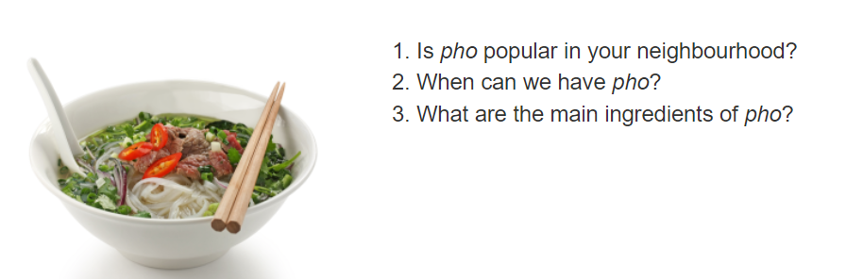
Procedure | - Have Ss look at the picture in the book or show the picture in the book on a slide. Ask Ss what they see in the picture.  - Have Ss work in pairs to discuss the three questions.  - Invite some Ss to share their answers. Tell Ss that they are going to read a text about “Pho”.
Outcome | 1. Ss express their thought about the topic hobbies  2. Expected answer:  - In the picture, I can see a bowl of beef noodle soup. This is a very popular kind of food in my neighborhood. The main ingredients are noodles, beef and broth.
Activity 3 : Guessing the meaning of new words in context. (5 minutes)
Goal | The activity aims at helping Ss develop the skill of guessing the meaning of new words in context.
Input | 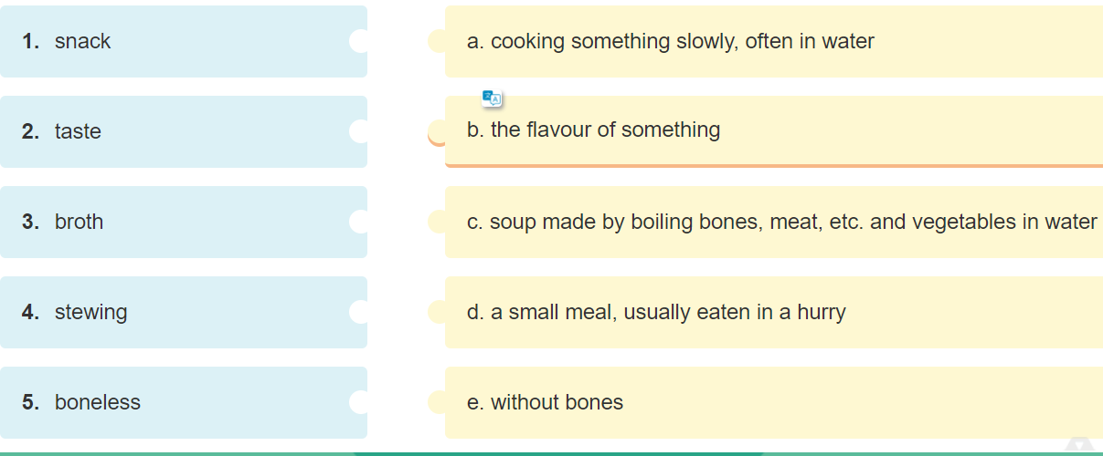
Procedure | Tell Ss what they are going to do.  - Ask Ss how to do the exercise. Elicit answers from Ss.  - If needed, tell them to follow these steps:  + Read the words in column A.  + Locate each word in the text.  + Read around the word to get the general meaning.  + Read the definitions in column B, find the suitable meaning to match each word.  - Ask Ss to repeat the steps (they can speak in Vietnamese).  - Ask Ss to do the exercise individually and then check their answers in pairs.  - Invite some Ss to share their answers. Confirm the correct answers
Outcome | 1. Ss can guess the vocabulary in context.  2. Key: 1.d 2.b 3.c 4. a 5.e
Activity 4: Reading (10 minutes)
Goal | The activity aims at helping Ss develop the skill of reading for specific information (scanning).
Input | 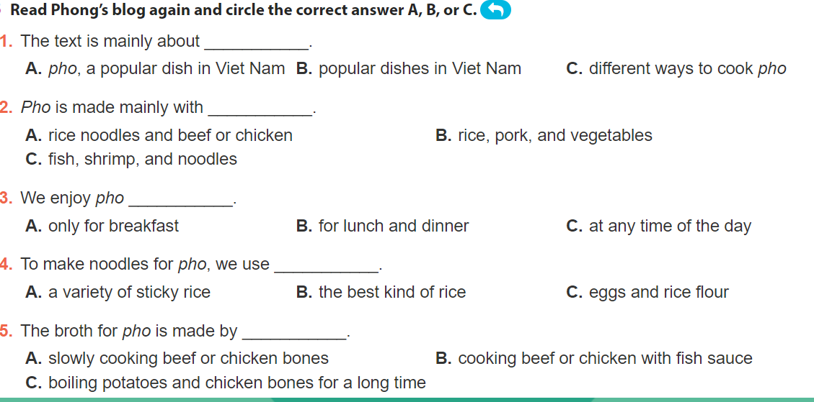
Procedure | - Ask Ss what they are going to do.  - Have Ss share how to do this exercise.  - Briefly tell them the steps: read the sentences, underline the key words in the sentences, locate the key words in the text and find the words to complete the sentences.  - Ask Ss to repeat the steps (they can speak in Vietnamese).  - Ask Ss to do the exercise individually and then check their answers in pairs.  - Invite some Ss to share their answers. Have them explain their answers. Confirm the correct answers.
Outcome | 1. Ss master the ways to read for specific information  2. - Key 1. A 2. A 3. C 4. B 5. A
Activity 5: Make notes about a popular food or drink, its ingredients, occasion to have it. (5 minutes)
Goal | The activity aims at helping Ss call out the food or drink and its ingredients.
Input | 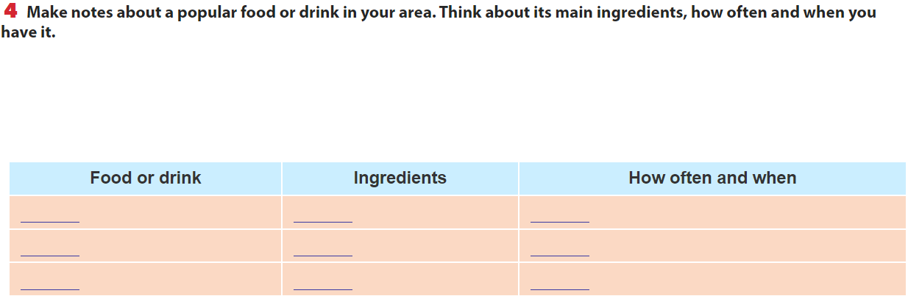
Procedure | - Give some examples.  - Have Ss work in pairs to compare their idea with the partner.  - Ask Ss to show their answer on bb.
Outcome | 1. Ss name kind of food and drink and its ingredients.  2. Expected answer:  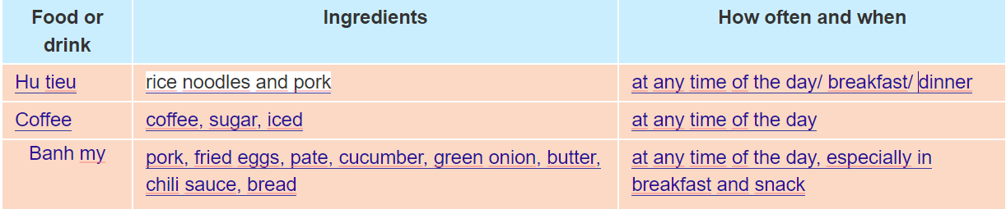
Activity 6: Asking and answering about the food and drink. (5 minutes)
Goal | The activity aims at practicing with asking and answering about the food and drink.
Input
Procedure | - Have Ss work in groups to ask and answer the two questions.  - Model the answers to the two questions if needed.  - Invite some Ss to share their partner's answers to the questions.  - Invite other Ss to comment on the answers.  - Comment on Ss' answers.
Outcome | 1. Ss master the ways to ask and answer about a popular food or drink.  2. Expected answer:  Pho is a popular dish in my area. Its main ingredients are rice noodles and slices of beef or chicken. It is one of the most common dishes you will find in Viet Nam. People enjoy pho at all times of the day, even for a late night snack.
Wrap-up: (5 minutes)
- Ask Ss to summarise what they have learnt in the lesson.
- Have Ss look at the objectives written on the board at the beginning of the lesson and tick the
objectives they can do.
- Prepare Skills 2 on page 56.
*EVALUATION:
………………………………………………………………………………………………………………………………………………………………………………………………………………………………………………………………………………………………………………………………………………………………………………………………
………………………………………………………………………………………………………………………………………………………………………………………………

Week: 13
Period: 39
Date of teaching: 29/11/2024
Lesson 6: UNIT5: SKILLS 2
Timing: 1 period (45 minutes)
I. Objectives
1.Knowledge: By the end of this unit students can:
a. Skills:
- Main skills
Listening: listen for specific information about eating habits of people in someone’s area.
Write: write a paragraph about the eating habits in their area.
- Sub skill:
Reading: complete the specific information in the table.
b. Language:
Vocabulary: use some vocabulary about food and drink
Grammar: use the present simple tense to write a paragraph about eating habits
2. Competence
Students can write a paragraph about eating habits of people in their area.
3. Attitude
Students can develop communication skills and creativity, be collaborative and supportive in pair work and teamwork and actively join in class activities
II. Teaching aids (& materials)
Student book TA 7, ppt file, pictures of food and drink
III. Procedure
Activity 1: Setting the scene (5 minutes)
Goal | The activity aims at creating an active atmosphere in the class before the lesson and leading into the new unit
Input | Game: Racing: What food and drink you had yesterday.
Procedure | - Divide Ss into 2 teams  - Go to the board and write as much food and drink as possible.  - Lead to the new lesson: Listening and Writing lesson about food and drink.  - Introduce the objectives of the lesson
Outcome | 1. Ss have an exciting atmosphere to start the lesson  2. Expected answers:  Bread, pho coffee, milk tea, noodles, …
Activity 2: Teaching new words (5 minutes)
Goal | The activity aims at providing students with vocabulary and helping students well-prepared for the listening and writing tasks.
Input | 1. eel (n) /iːl/ con lươn  2. toast (n) /təʊst/ bánh mì nướng  3. green tea (n) /ˌɡriːn ˈtiː/ chè xanh, trà xanh
Procedure | – follow steps of teaching new vocabulary  - use “RUB OUT AND REMEMBER”to check vocabulary
Outcome | 1. Ss have certain vocabulary for the listening and writing tasks.  2. three new words
Activity 3: Activating Ss' knowledge of the topic (5 minutes)
Goal | The activity aims at activating Ss' knowledge of the topic of the reading text.
Input | 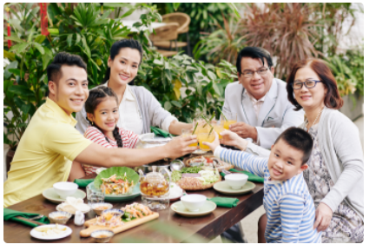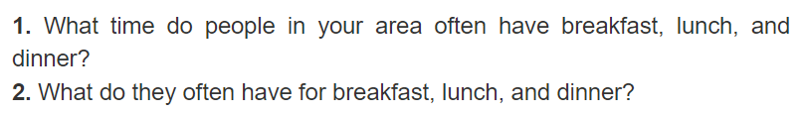
Procedure | - Have Ss look at the picture and answer the questions.  - Ask Ss if they know anything about this habit and if they think it is useful. This is an open activity, so accept all answers provided that they make sense.
Outcome | 1. Ss express their thought about the topic hobbies  2. Expected answer:  - They usually have breakfast at 6.30 a.m. They usually have lunch at 11 p.m. They usually have dinner at 7 p.m.  - They eat a light breakfast with many kinds of foods like pho, bread and milk. At lunch, they eat rice with many dishes. And at dinner, they have a big dinner with fish, meat, or vegetables.
Activity 4: Listening for specific information. (5 minutes)
Goal | The activity aims at helping Ss:  - understand what the monologue is about.  - develop the skill of listening for specific information.
Input | 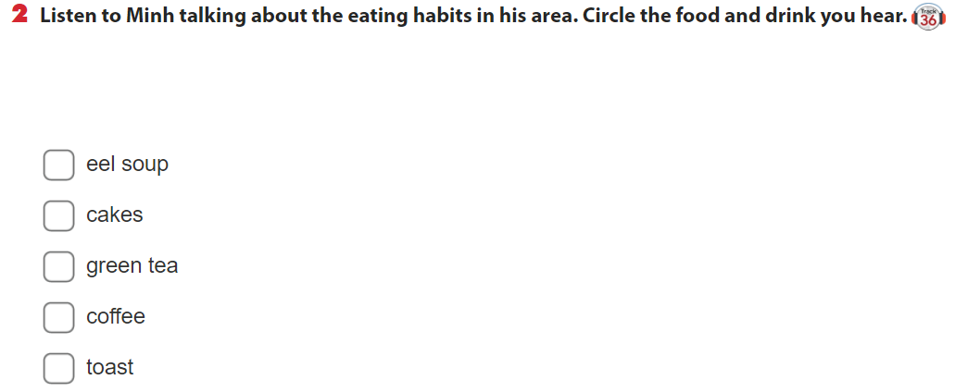
Procedure | - Tell Ss that they are going to listen to Minh talking about the eating habits in his area.  - Have Ss read the table. Have Ss guess what food and drink will appear in the monologue.  - Play the recording and ask Ss to tick the words or phrases they hear from the monologue. Then ask two or three students to write their answer on the board.  Ss work in pairs to compare their answers with each other.  - Play the recording a second time for pairs to check their answers.
Outcome | 1. Ss can guess the vocabulary in context.  2. Key: 1. Eel soup 2. Green tea
Activity 5 : Listening for specific information ( 5 minutes)
Goal | The activity aims at helping Ss develop the skill of listening for specific information.
Input | 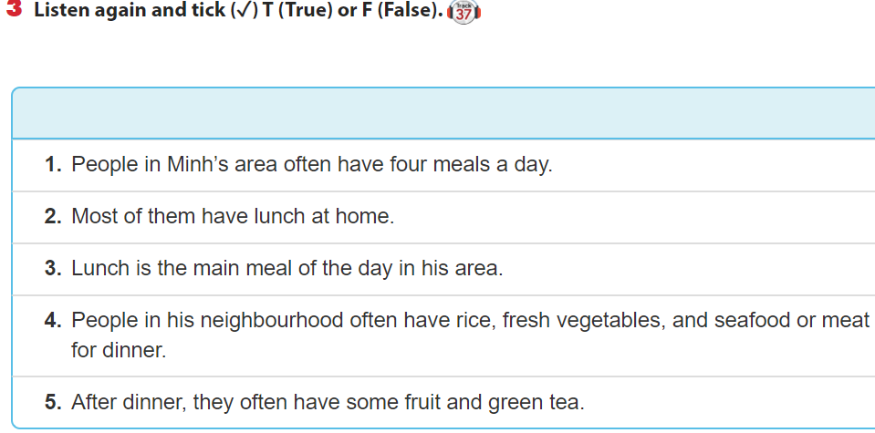
Procedure | - Have Ss look at the statements and ask them how to do this exercise.  - Give Ss some strategies to do the exercise: reading the sentences, underlining the key words, listening to the recording paying attention to the key words, deciding if each sentence is true or false.  - Play the recording twice for Ss to listen.  - Have Ss to share their answers with the partner.
Outcome | Key 1. F 2. T 3. F 4. T 5. T

Activity 6: Brainstorming ideas for the writing (5 minutes)
Goal | The activity aims at helping Ss prepare ideas for their writing.
Input | 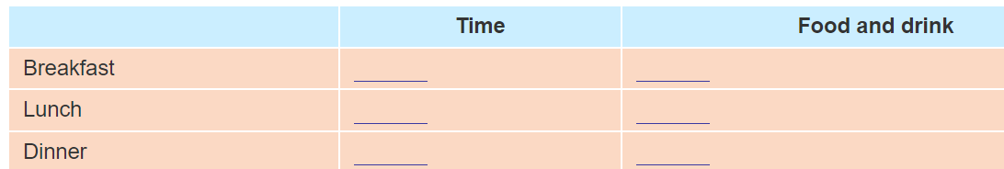
Procedure | - Have Ss to make notes about the eating habits in their area.  - Ask Ss to share their notes with their partner.
Outcome | 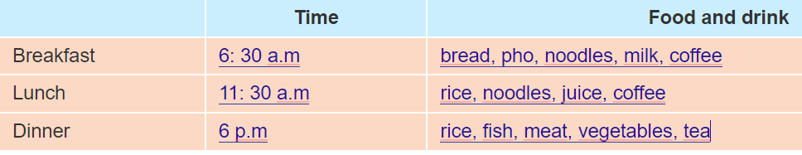
Activity 7: Write a paragraph about the eating habits. (10 minutes)
Goal | The activity aims at helping Ss practice writing a paragraph about the eating habits in their area.
Input
Procedure | - Have Ss write their paragraphs individually based on the information in their table.  - Ask one student to write his or her paragraph on the board. Other Ss and T comment on the paragraph on the board.  - Then T collects some writings to correct at home.
Outcome | 1. Ss can write a paragraph about the eating habits in their area.  2. Expected answer:

Wrap-up: [5 minutes]
- Ask Ss to summarise what they have learnt in the lesson.
- Have Ss look at the objectives written on the board at the beginning of the lesson and tick the
objectives they can do.
- Prepare Project.
*EVALUATION:
………………………………………………………………………………………………………………………………………………………………………………………………………………………………………………………………………………………………………………………………………………………………………………………………
………………………………………………………………………………………………………………………………………………………………………………………………

DUYỆT CỦA TỔ TRƯỞNG NGƯỜI SOẠN

Phạm Thị Tuyết Hoa Đỗ Thị Thu Hằng

