Date of preparing: 22/12/2024 Period: 49
Date of teaching: 24/12/2024 Week: 17
TEACHING PLAN
Lesson 2: REVIEW 2 – SKILLS (Unit 4-5-6)
Timing: 1 period (45 minutes)
I. Objectives:
1.Knowledge: By the end of this unit students can:
a. Skills:
- Reading: practice reading for specific information about an event schedule.
- Speaking: practice talking about the reasons for people moving from the countryside to the city.
- Listening: practice listening for specific information about life in the countryside.
- Writing: practice writing correct sentences from clues.
b. Language:
Vocabulary: Review vocabulary , Pronunciation in Units 4-5-6
Grammar: Grammar in Units 4 -5-6
2. Competence
Students can develop communication skills, creativity and cultural awareness, be collaborative and supportive in pair work and teamwork, and actively join in class activities.
3. Attitude
Students can develop self-study skills and know the importance of revision and need to study harder.
II. Teaching aids (& materials)
- Grade 8 textbook, Review 2 – Skills.
- Computer connected to the Internet
- Projector / TV
- ppt file,
III. Procedure
Activity 1: Warming-up (5 minutes)
Goal | The activity aims at creating an active atmosphere in the class before the lesson and leading into the new unit
Input | Chatting: CUSTOMS AND TRADITIONS  Customs and traditions
 | - Teacher asks Ss to work individually and think of the customs and traditions that they know in their neighbourhood. - Teacher calls on some Ss to give their ideas. - Teacher gives comments and leads Ss to the new lesson.
Outcome | 1. Ss have an exciting atmosphere to start the lesson  2. Expected answers: 1. Ancestor Worship 2. Visiting the pagoda 3. Lunar New Year reunion, 4. wear aodai on speacial occasion 5. Respect old people 6. Take things from adults with both hand…….
Activity 2: reading (9 minutes)
Goal | The activity aims at helping students practise reading an event schedule for specific information.
Input | Read the schedule of the Spring Fair and select the event that each person wants to attend. Write the event names in the table.
Procedure | - Teacher familiarise Ss with quite a new genre, event schedule, by asking them to look quickly at the text and answer “What’s the name of the event?”, “When is it?”, Where is it?”, “What events are there at the fair?”. The answer to the last question would help guide Ss where to look for the information to answer the questions in the exercise.  – Teacher asks Ss to do the exercise individually. Guide them to read the information in the table about each people first, then decide the event for them.  – Teacher calls on some Ss to share their answers with the class.  – Teacher confirms the correct answers as a class and explains if needed
Outcome | Answer key:  1. Childhood Fun 2. A Pottery Village  3. Performances 4. Ethnic Markets  5. Photo Exhibition

Activity 3 :speaking (8 minutes)
Goal | The activity aims at helping students have an opportunity to talk about why they think people are moving to the city
Input | Work in pairs. Read the list below and tick (√) the main reason(s) for people moving from the countryside to the city. Explain your choice.  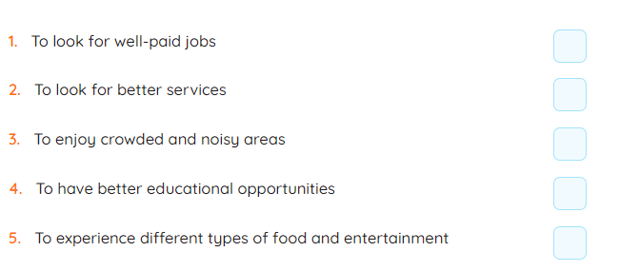
Procedure | - Teacher has Ss work in pairs or groups.  - Teacher asks Ss to read the list, discuss and tick the reason(s) they all agree with.  - Teacher allows Ss some time to talk, and maybe take notes of their explanations.  - Teacher calls on some pairs or groups to report their answers to the class. Each pair or group may answer just one question to allow time for more pairs and groups.  - Teacher listens and comments, especially on the explanations.
Outcome | - Students can talk about the main reason(s) for people moving from the countryside to the city and explain their choice.

Activity 4 : Listening (8 minutes)
Goal | The activity aims at helping students practise listening for specific information
Input | Listen to Phong talking about life in the countryside and complete each sentence with one word.  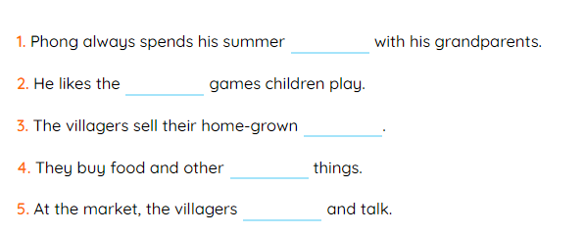
Procedure | - Teacher asks Ss to read the sentences first to get an overall idea of what they are going to listen and to decide what information they need to answer the questions.  - Teacher plays the recording and allows Ss some time afterwards to complete their answers.  - Teacher checks the answers as a class. If needed, plays the recording again and pauses when an answer comes.  - Teacher confirms the correct answers as a class.
Outcome | Answer key:  1. vacation 2. traditional 3. products 4. necessary 5. meet

Activity 5 : Writing ( 10 minutes)
Goal | The activity aims at helping ss practise practice in writing correct sentences from clues.
Input | Write complete sentences from the clues below.  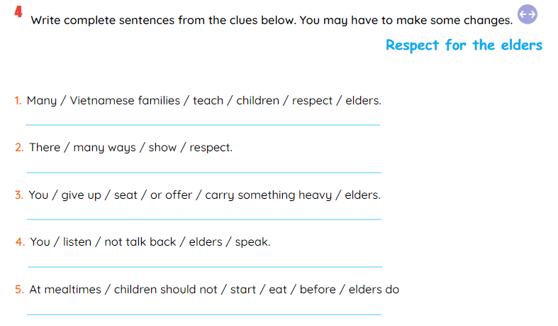
Procedure | - Teacher asks Ss to read the clues of the whole text to have a general idea of what the text is about and what tense is most suitable for each sentence.  - Teacher asks Ss to work individually.  - Teacher allows Ss some time to complete the sentences.  - Teacher calls on some Ss to read aloud their sentences.  - Teacher gives comments.  - Teacher provides correct sentences. Explains if needed.
Outcome | Answer key:  1. Many Vietnamese families often teach their children to respect the elders.  2. There are many ways to show respect.  3. You can give up a seat or offer to carry something heavy for the elders.  4. You should listen and don’t talk back when the elders speak.  5. At mealtimes, children should not start eating before the elders do.
Wrap-up: ( 5 minutes)
- Ask Ss to summarise what they have learnt in the lesson.
- Do exercises in the workbook.
- Prepare for Unit 7 – Getting started
……………………………………………………………………………………………………
* Date of teaching : 24/12/2024
* Week : 17
* Period : 50
REVISION FOR THE 1ST TERM EXAMINATION
A. Objectives : By the end of the lesson, Ss will be able to review the important knowledge in Unit 1,2,3,4,5,6
B. Language Contents:
- Vocabulary:
- Grammar:
- Skills: listening, speaking, reading and writing skills
C. Teaching aids:
Textbook, sach mem, tieng anh 123, powerpoint, word
D. Procedures:
Write the letter A, B, C, or D on your answer sheet to indicate the word whose underlined part differs from the other three in pronunciation in each of the following questions.
Question 9: A. resort B. prefer C. stretch D. detest
Question 10: A. greeted B. maintained C. revived D. arrived
Write the letter A, B, C, or D on your answer sheet to indicate the word that differs from the other three in the position of primary stress in the following question.
Question 11: A. preservation B. performance C. companion D. attention
Write the letter A, B, C, or D on your answer sheet to indicate the correct answer to each of the following questions.
Question 12: _______ sugar is not good for your teeth.
A. Ø B. a C. the D.an
Question 13: People in the countryside are _______ than people in the city.
A. more hospitable B. hospitable more
C. The more hospitable D. the most hospitable
Question 14: I am crazy about _______ stories
A. read B. reading C. reads D. to read
Question 15: Tet is an occasion for family _______ in Viet Nam.
A. visitings B. meetings C. reunions D. seeings
Question 16: Nga invites Hoa to hang out with her.
Nga: “Would you like to hang out with me?” - Hoa: “_______.”
A. No, I don’t like B. Never mind
C. Yes, I’d love to D. Yes, I’d like
Question 17: Tet’s _______ is the longest holiday which may last up to seven to nine days.
A. celebrate B. celebrated C. celebratory D. celebration
Write the letter A, B, C, or D on your answer sheet to indicate the word(s) CLOSEST in meaning to the underlined word(s) in the following question.
Question 18: We usually play chess in my free time
A. happy time B. boring time C. leisure time D. timetable
Write the letter A, B, C, or D on your answer sheet to indicate the word(s) OPPOSITE in meaning to the underlined word(s) in the following question.
Question 19: My mom is keen on cooking.
A. loves B. hates C. like D. enjoy
Write the letter A, B, C, or D on your answer sheet to indicate the underlined part that needs correction in each of the following questions.

Question 20: How many water do you drink everyday?
A. do B. How many C. drink D. everyday
Question 21: A camel runs much more slowly as a horse.
A. much B. as C. runs D. A
Question 22: What he detests to do is going to work at weekends.
A. detests B. weekends C. going D. to do
Read the following passage and write the letter A, B, C, or D on your answer sheet to indicate the correct word or phrase that best fits each of the numbered blanks.
There are many reasons why it (23) _______ important to have a hobby. It will give you a pleasure and help you relax. Many old people enjoy gardening. They (24) ______a lot of trees and vegetables, so they can sell them for some money. In addition, a hobby can help you connect with other people. If you like (25) _______stamps, you can join a stamp club to share your albums with other collectors. If your hobby is carving eggshells, you can give your products to your friends (26) _______ gifts.
Question 23: A. have B. do C. are D. is
Question 24: A. grows B. to grow C. growing D. grow
Question 25: A. collecting B. playing C. selling D. gardening
Question 26: A. as B. for C. in D. with
Read the following passage and circle the letter A, B, C, or D to indicate the correct answer to each of the questions.
In Viet Nam, a market is a trading place, but many markets are not only about buying and selling things. They reflect the life of the community. A traditional market is a social gathering point for people of all ages and it is a new and exciting experience for children, a trading place for local craftsmen, and a chance for young people to meet. People go to the traditional market not only to buy and sell things but also to eat, drink, play games, and socialize. For example, if you go to Sa Pa Market, which is the highlands in the north of Viet Nam, you can see people wearing their nicest clothes and spending all day long at the market. They buy things, play the flute, dance, and sing. This is also a time to meet, make friends or look for lovers. That is why this kind of gathering is also called "Love Market”. Some other countryside markets in the Mekong Delta are held on boats. Most of the goods are sold at a floating market. The most exciting time is in the early morning when boats arrive loaded up with agricultural products.
27. In Viet Nam, all markets are ______________.
A. only exciting places B. only about buying things
C. only about selling things D. not only about buying and selling things
28. A traditional market is a social gathering point for ______________.
A. young people B. people of all ages
C. local craftsmen D. children
29. What can people do at the traditional market?
A. Sell and buy things only.
B. Buy and sell things, eat, drink and play games.
C. Buy things and eat.
D. Buy and sell things, eat, drink, play games and socialize.
30. What do the ethnic people who go to Sa Pa Market do?
A. They wear their nicest clothes, buy things, play the flute, dance and sing.
B. They ride on a horse and sing.
C. They drink a lot of wine and dance.
D. They buy the nicest clothes at the market and look for lovers.
SECTION B
I. Finish each of the following sentences in such a way that it means the same as the sentence printed before it. Write your answers on your answer sheet. (0,5 point)
Question 1: A racing driver drives more skillfully than a normal motorist.
→ A normal motorist drives __________________________________________.
Question 2: I am interested in going camping with my close friends.
→I fancy __________________________________________________________.

* Date of teaching : 2/12/2024
* Week : 17
* Period : 51
REVISION FOR THE 1ST TERM EXAMINATION
A. Objectives : By the end of the lesson, Ss will be able to review the important knowledge in Unit 1,2,3,4,5,6
B. Language Contents:
- Vocabulary:
- Grammar:
- Skills: listening, speaking, reading and writing skills
C. Teaching aids:
Textbook, sach mem, tieng anh 123, powerpoint, word
D. Procedures:
Write the letter A, B, C, or D on your answer sheet to indicate the word whose underlined part differs from the other three in pronunciation in each of the following questions.
Question 9: A. books B. floors C. combs D. drums
Question 10: A. concerned B. received C. attached D. concealed
Write the letter A, B, C, or D on your answer sheet to indicate the word that differs from the other three in the position of primary stress in the following question.
Question 11: A. preservation B. performance C. companion D. attention
Write the letter A, B, C, or D on your answer sheet to indicate the correct answer to each of the following questions.
Question 12: My parents always tell me that I should _______things from adults with both hands.
A. takes B. taking C. take D. have taken
Question 13: My sister loves ___________ the elderly people in our neighborhood.
A. help B. to help C. helps D. helped
Question 14: _________ spring comes , many Vietnamese villages prepare for a new festival season.
A. While B. When C. Nevertheless D. However
Question 15: Tet is an occasion for family _________ in Viet Nam.
A. visitings B. meetings C. reunions D. seeings
Question 16: A: Hello, I’m from Australia. Can I ask you something about the ethnic groups of Viet Nam ?
B: "____"
A. Good. B. Really. C. Sure. D. Thanks.
Question 17: Tet’s ________ is the longest holiday which may last up to seven to nine days.
A. celebrate B. celebrated C. celebratory D. celebration
Write the letter A, B, C, or D on your answer sheet to indicate the word(s) CLOSEST in meaning to the underlined word(s) in the following question.
Question 18: Nomadic people live in a ger. It keeps them cool in summer and warm in winter.
A. yatch B. house C. cave D. circular tent
Write the letter A, B, C, or D on your answer sheet to indicate the word(s) OPPOSITE in meaning to the underlined word(s) in the following question.
Question 19: The Kinh have the largest number of people about 86% of the population. 53% others are called ethnic minority people.
A. smallest B. little C. much D. majority
Write the letter A, B, C, or D on your answer sheet to indicate the underlined part that needs correction in each of the following questions.

Question 20: How many water do you drink everyday?
A. do B. How many C. drink D. everyday
Question 21: A camel runs much more slowly as a horse.
A. much B. as C. runs D. A
Question 22: In the past, Vietnamese people have to live with their parents even after they got married.
A. In B. have to C. even D. got
Read the following passage and write the letter A, B, C, or D on your answer sheet to indicate the correct word or phrase that best fits each of the numbered blanks.
The country and the city have both advantages and (23) ________. People in the country live in more beautiful surroundings. They enjoy (24) ________ and quietness, and can do their work at their own space because no one is in a (25) ________. They live in larger, more comfortable houses, and their neighbors are friendlier, and ready to help them (26)________ they need it. Their life, however, can be boring and they may be isolated, which is a serious problem if they are ill or want to take children to school.
Question 23: A. joy B. enjoyment C. happiness D. disadvantages
Question 24: A. quiet B. quietly C. peace D. peaceful
Question 25: A. hurry B. hurried C. hurriedly D. hurrying
Question 26: A. when B. which C. why D. that
Read the following passage and circle the letter A, B, C, or D to indicate the correct answer to each of the questions.
GONG CULTURE IN THE CENTRAL HIGHLANDS
Gong culture in the Central Highlands of Viet Nam has been recognized by UNESCO as a Masterpiece of the Intangible Heritage of Humanity.
Gong culture covers five provinces of the Central Highlands : Kon Tum, Gia Lai, Dak Lak, and Lam Dong.The masters of gong culture are the ethnic groups of Bahnar, Sedang, Mnong, Coho, Ede, Giarai… The Gong Festival is held annually in the Central Highlands. In the festival,artists from these provinces give gong performances, highlighting the gong culture of their own province.
For the ethnic groups of the Central Highlands, gong are musical instruments of special power. It is believed that every gong is the symbol of a god who grows more powerful as the gong gets older. Therefore, gongs are associated with special occasions in peoples’ lives, such as the building of new houses, funerals, crops praying ceremonies, a new harvest, victory celebrations, ect. The gong sound is a way to communicate with the gods.
Question 27: The text tells us about________.
A. a world culture heritage B. the artists of the Central Highlands
C. life in the Central Highlands D. musical instruments of ethnic groups
Question 28: How often the Gong Festival celebrated ?
A. every year B. every month
C. on special occasions D. all the year round
Question 29: The gongs are________.
- a of art work B. pieces of folk music
C. musical instruments. D. cultural heritages
Question 30: The ethnic people in the Central Highlands believe that________.
- special powers like their gongs B. gongs are associated with new houses
C. their gongs are symbols of gods D. the gong is older than themselves
SECTION B
I. Finish each of the following sentences in such a way that it means the same as the sentence printed before it. Write your answers on your answer sheet. (0,5 point)
Question 1: A racing driver drives more skillfully than a normal motorist.
→ A normal motorist drives __________________________________________.
Question 2: I am interested in going camping with my close friends.
→I fancy __________________________________________________________.

DUYỆT CỦA TỔ TRƯỞNG NGƯỜI SOẠN

Phạm Thị Tuyết Hoa Đỗ Thị Thu Hằng

