Date of preparing: 15/12/2024 Period: 46
Date of teaching: 17/12/2024 Week: 16
Lesson 6: UNIT 6: LIFESTYLES- SKILLS 2
Timing: 1 period (45 minutes)
I. Objectives
1.Knowledge: By the end of this unit students can:
a. Skills:
- Main skills
Listening: listen for someone’s opinion about the impact of modern technology
Writing: Write a paragraph about the advantages or disadvantages of online learning
- Sub skill:
Reading: complete the specific information in a mind map
b. Language:
Vocabulary: use some vocabulary about the lifestyles
Grammar: use the present simple tense to write a paragraph about the advantages or disadvantages of online learning.
2. Competence
Students can write a paragraph about the advantages or disadvantages of online learning.
3. Attitude
Students can develop communication skills and creativity, be collaborative and supportive in pair work and teamwork and actively join in class activities
II. Teaching aids (& materials)
Student book TA 8, ppt file, pictures of online learning.
III. Procedure
Activity 1: Setting the scene (5 minutes)
Goal | The activity aims at creating an active atmosphere in the class before the lesson and leading into the new unit
Input | Broken telephone
Procedure | - T divides the class into 5 groups. Each group stands in one line. T shows a word to the last students of all groups. These students must quickly whisper the word to their teammates in order. The first member of each team writes the word on the board. The fastest student writes the correct word earns 1 point for the team.  - T leads to the new lesson: Listening and Writing about opinions on technology and online learning.  - T introduces the objectives of the lesson.
Outcome | 1. Ss have an exciting atmosphere to start the lesson  2. Expected answers:  - lifestyle  - communication  - online learning  - technology
Activity 2: Listening (5 minutes)
Goal | The activity aims at providing students with vocabulary and helping students well-prepared for the listening and writing tasks.
Input | Work in groups. Which of the following do you think is more influenced by modern technology? Tick your choice(s).
Procedure | - Let Ss work in groups. Give them 2 - 3 minutes to think and tick the correct answer(s).  - Ask some Ss to share their answers in front of the class. If necessary, T may ask them some other questions about the reasons for their answers.
Outcome | - Expected answers:  - ways of communicating  - ways of learning
Activity 3 : Activating Ss' knowledge of the topic (5 minutes)
Goal | The activity aims to help Ss develop the skill of listening for specific information.
Input | Listen to the conversation and tick (✓) T (True) or F (False).
Procedure | - Have Ss read the questions in this activity quickly and underline the key words. This helps them have some idea of what they are going to listen to and the information they need for answering the questions.  - Tell Ss that they are going to listen to a conversation about modern technology and online learning.  - Play the recording twice for Ss to do the exercise. For stronger  classes, ask Ss to take notes of the information to explain their answers.  - Have Ss share their answers in pairs.  - Invite some pairs to answer and confirm the correct ones.  Play the recording again if needed, stopping at places where Ss are having difficulties.
Outcome | 1. Ss express their thought about the topic leisure activity  2. Expected answer:  - T  - T  - F  - F  - T
Activity 4 : Listening for specific information. (10 minutes)
Goal | The activity aims at helping Ss develop the skill of listening for specific information.
Input | Listen again and choose the correct answer to each question.
Procedure | - Have Ss read the questions and the options, and quickly underline the key words.  - Have Ss read through the sentences first.  - Play the recording once or twice. Ask Ss to listen carefully and circle the correct answers.  - Have Ss share their answers in pairs.  - Invite some pairs to answer and confirm the correct ones.  - Play the recording again if needed, stopping at the places where Ss are having difficulties.
Outcome | 1. Ss can guess the vocabulary in context.  2. Key:  - A  - B  - C  - C
Activity 5 : Brainstorming ideas and making an outline for writing ( 5 minutes)
Goal | The activity aims at helping Ss brainstorm ideas and make an outline for Ss' writing.
Input | Look at the list below. Put the ideas about online learning in the correct column.
Procedure | - Have Ss work in pairs. Tell them to read all the ideas given, think about them and put them in the correct column.
Outcome | 1. Ss have ideas and an outline for Ss' writing  2. Key  - Advantages: convenient, comfortable, more freedom, independent  - Disadvantages: difficult to concentrate, no real interaction, harmful to our eyes, expensive equipment
Activity 6 : Writing a paragraph about the advantages or disadvantages of online learning. ( 10 minutes)
Goal | The activity aims at helping Ss practise writing about the advantages or disadvantages of online learning.
Input | Write a paragraph (80 – 100 words) about the advantages OR disadvantages of online learning. You can refer to the listening and the ideas in 4.
Procedure | - Set up the writing activity: T reminds Ss that the first important thing is always to think about what they are going to write. Ss can use the ideas they have prepared in 4. Ask Ss to brainstorm the ideas and needed language for writing.  - Set a time limit for Ss to write the paragraph. Tell them to use proper connectors (first/ firstly, second/ secondly, etc.), and pay attention to grammar, use of words, spelling and punctuation.  - Ask Ss to write the first draft individually. T may display all or some of the Ss’ writings on the wall / bulletin board. T and other Ss comment. Ss edit and revise their writing as homework. If time is limited, T may ask Ss to write the final version at home.
Outcome | - Ss can write an email about the advantages OR disadvantages of online learning.  2. Expected answer:  Online learning is becoming more and more popular, but it has several disadvantages. Firstly, it is very difficult for students to concentrate as they lack face-to-face interaction with their teachers and friends. Secondly, looking at the screen constantly is harmful to students’ eyes, and it causes tiredness, so it is not easy for students to work for too long. Thirdly, working online needs expensive equipment, such as a computer or laptop as well as Internet connection. For these reasons, I prefer going to school and having offline lessons, so that I can meet my teachers and friends every day.
Wrap-up: ( 5 minutes)
- Ask Ss to summarise what they have learnt in the lesson.
- Have Ss look at the objectives written on the board at the beginning of the lesson and tick the
objectives they can do.
……………………………………………………………………………………………………………………………………………………….
Date of preparing: 15/12/2024 Period: 46
Date of teaching: 17/12/2024 Week: 16
Lesson 7 : UNIT 6: LIFESTYLES
(LOOKING BACK)

I. Objectives:
1. Knowledge: By the end of this unit students can be able to
- review the vocabulary and grammar of Unit 6
- apply what they have learnt (vocabulary and grammar) into practice through a project.
2. Competence:
Students can use future simple tense and first conditional.
3. Attitude:
Students can develop communication skills and creativity, be collaborative and supportive in pair work and teamwork and actively join in class activities
II. Teaching aids (& materials):
Student book TA 7, ppt file, pictures of different lifestyles.
III. Procedure:
Activity 1: Setting the scene (5 minutes)
Goal | The activity aims at creating an active atmosphere in the class before the lesson and leading into the new unit
Input | CHATTING
Procedure | - Teacher asks Ss to think of what they have learnt already in Unit 6.  - Ss work in pairs to do the task. Teacher calls some students to retell.  - Teacher confirms and leads them to do all the exercises in books.
Outcome | 1. Ss have an exciting atmosphere to start the lesson  2. Expected answers:  - use the words related to the topic lifestyles;  - pronounce the sounds /br/ and /pr/ in words and sentences correctly;  - use the future simple and the first conditional;  - express certainty;  - read for specific information about an interesting lifestyle and ways to maintain a traditional lifestyle;  - talk about maintaining traditional lifestyles;  - listen for general and specific information about the impact of modern technology on lifestyles;  - write a paragraph about the advantages or disadvantages of online learning.
Activity 2 : Match each word or phrase with its meaning. (5 minutes)
Goal | The activity aims at helping ss identify the meaning of the words.
Input | Match each word or phrase with its meaning.
Procedure | - Have Ss do these activities individually then compare their answers with their partners.  - Ask for Ss’ answers or ask some Ss to read out their answers in front of the class.  - Confirm the correct answers.
Outcome | Answer key:  - c  - d  - e  - a  - b
Activity 3 : Complete each sentence with a word or phrase from the box.(5 minutes)
Goal | The activity aims at helping Ss complete each sentence with a word or phrase from the box.
Input | Complete each sentence with a word or phrase from the box.
Procedure | - Ask Ss to read the words and phrases in the box first.  - Have them study the sentences. Tell them to pay attention to the gaps, and what words / phrases they need to fill them in.  - Tell Ss to write the answers in their notebooks. Ask some of them to write their answers on the board. Correct mistakes if necessary.
Outcome | Key:  - in the habit of  - greeted  - lifestyle  - online lessons  - maintain
Activity 4 : Complete the sentences, using the correct tense of the verbs in brackets. ( 5 minutes)
Goal | The activity aims at giving further complete the sentences, using the correct tense of the verbs in brackets.
Input | Complete the sentences, using the correct tense of the verbs in brackets.
Procedure | - T may have Ss review the form and uses of the future simple before they do the task.  - Ask Ss to do the exercise individually first. Then they can check their answers with a partner before discussing the answers as a class.  - Remind Ss to keep a record of their original answers so that they can use that information in the Now I can … section.
Outcome | Suggested answers:  - will send  - won’t be  - will become  - win  - Will we have to
Activity 5 : Rewrite the following sentences, so that their meaning stays the same.( 5 minutes)
Goal | The activity aims at helping Ss do further rewrite the following sentences, so that their meaning stays the same.
Input | Rewrite the following sentences, so that their meaning stays the same.
Procedure | - Allow Ss some time to do the task individually and write the sentences in their notebooks.  - Then ask Ss to compare their answers in pairs.  - T may call on some Ss to write their answers on the board, other Ss give comments, and T checks them as a class.
Outcome | Answer key:  - If you play computer games for too long, you will harm your eyes.  - You will get overweight unless you are careful with what you eat.  - If it doesn’t rain, we’ll go to the beach. / If it rains, we won’t go to the beach.  - Unless you hurry up, you will be late.  - If the teacher doesn’t explain the lesson again, we won’t understand it very well.
Activity 6: Making a project of Unit 6. (15 minutes)
Goal | After this activity, students develop the skill of speaking and writing through making a poster and giving a presentation to the class
Input | Task 2 and 3: Make a poster to introduce the people and give a presentation to the class
Outcome | Sample report:  Everyday life: The life of Mongolian is punctuated by caring animals. A Mongolian nomadic family has five types of animals: horses and sheep for hot season and cows, camels and goats for cold season. Several times during the year, according to the needs of livestock and pasture conditions, nomadic families move their yurts. In summer, the nomadic family will favor a location near a river, to ensure water supply for the family and herds, and good pastures. In winter, the priority is given to protection against the intense cold of Mongolian winter, and the family settles its "winter" camp sheltered from the wind in a small valley or at the edge of a forest. The woman is very busy with the household, kitchen, 2 or 3 children, and milking the mares, cows... at least five times a day. The husband watches the herds of yaks, horses, cows and sheep scattered on often significant surfaces and must gather them every night to protect them against the wolf attacks, frequent in Mongolia. He also deals with equipment maintenance and repairs.  Ways of cooking: In traditional Mongolian cooking, seasoning was not used; although salt was there a long time and it is used it even in tea! Typically, they cook with a wok and most of the foods are either boiled or stir-fried. Since a lot of livestock is raised in Mongolia, it is no mystery that Mongolian cuisine revolves around them. Sheep and goat are most popularly which are either grilled or boiled. Traditionally soup and dumplings used to be in all the courses of the meals, without which, it was regarded to be incomplete. There are many types of crafts can be found in Mongolian culture: wooden sculptures, ger - nomadic dwelling, metalwork, embroidery art, leather crafting, art of jewelery. The traditional masterpiece of Mongolian is the urtyn duu accompanied with the morin-khurr. Most famous Mongolian dance are: Jinai dance (milking dance), the Caihong dance (rainbow dance), the Zhongwan dance (bowl dance), the Kuaizi dance (chopsticks dance), and the Andai dance. There are lots of festival in Mongolia but these are the most well-known one: Tsagaan Sar (Lunar New Year); Khovsgol Ice Festival; Naadam Festival; Gongoriin Bombani Hural; Ölgii Eagle Festival.
Procedure | - Ask them to work in group to discuss to design a poster of an interesting way of life around the world at home and make a presentation in front of the class  - Ask them to use ideas of the group, base on activites in textbook and design a nice poster and discuss to make a presentation in front of the class  - Call all groups to stick their posters on the board and make a presentation in front of the class  - Listen, check their pronunication, grammar and vocabulary in the class  - Give feedback to their posters and presentations and wishes in front of in the class

Wrap-up: ( 5 minutes)
- Ask Ss to summarise what they have learnt in the lesson. Have Ss look at the objectives written on the board at the beginning of the lesson and tick the objectives they have learnt.

Date of preparing: 18/12/2024 Period: 48
Date of teaching: 20/12/2024 Week: 16
TEACHING PLAN
Lesson 1: REVIEW 2 – LANGUAGE (Unit 4-5-6)
Timing: 1 period (45 minutes)

I. Objectives
1.Knowledge: By the end of this unit students can
a. Skills:
- Main skill : language skills such as pronunciation, vocabulary, grammar.
- Sub- skills:
+ Speaking: practice speaking intonation.
+ Listening: practice listening about sentence stress.
+ Writing: write sentences
b. Language:
Vocabulary: revise vocabulary unit 4, 5, 6
Grammar: - revise the sounds /k/, /g/, /n/, /ŋ/, /br/ and /pr/.
- revise the use of articles, types of questions, countable and uncountable nouns, simple future tense and first conditional.
2. Competence
Students can develop communication skills, creativity and cultural awareness, be collaborative and supportive in pair work and teamwork, and actively join in class activities.
3. Attitude
Students can develop self-study skills and know the importance of revision and need to study harder.
II. Teaching aids (& materials)
- Grade 8 textbook, Review 2 – Language.
- Computer connected to the Internet
- Projector / TV
- ppt file,
III. Procedure
Activity 1: Warming-up (5 minutes)
Goal | The activity aims at creating an active atmosphere in the class before the lesson and leading into the new lesson
Input | * Brainstorming:  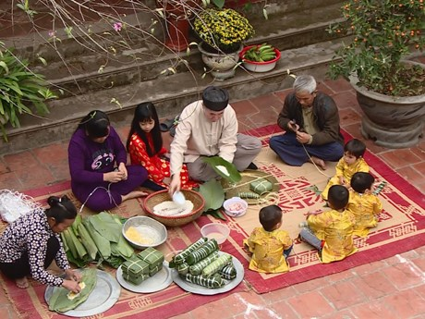
- Teacher shows 3 pictures (about Unit 4-5-6) and asks students to find a keyword for each picture.
- Students work individually, look at the pictures and guess the topic.
- Students raise hands to answer.
- Teacher and students discuss the answers.
- Teacher checks the answers as a class.
Outcome | Answer key: 1. Ethnic groups of Viet Nam 2. Our customs and traditions 3. Lifestyles

Activity 2: Pronunciation (7 minutes)
Goal | The activity aims at helping students revise the sounds /k/, /g/, /n/, /ŋ/, /br/ and /pr/.
Input | Circle the word which has the underlined part pronounced differently in each group. then listen and repeat  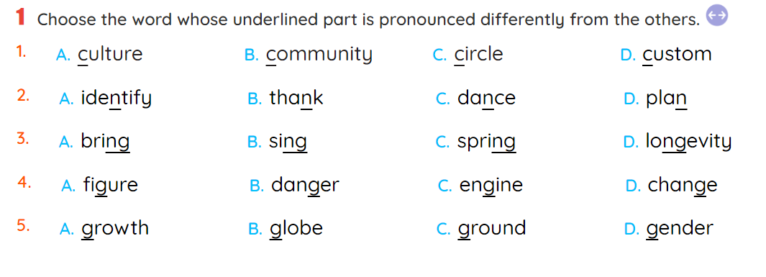
Procedure | - Teacher writes some words containing the sounds:  /k/, /g/, /n/, /ŋ/, /br/ and /pr/ .  - Teacher underlines the letter(s) containing the sounds.  - Teacher asks Ss to read the words on the board aloud and corrects them if needed.  - Teacher allows Ss some times to do the exercise.  - Ss work individually and circle the words.  - Teacher plays the recording for Ss to listen and check their answers.  - Teacher calls on some Ss to share their answers.  - Teacher confirms the correct answers as a class.  - Teacher plays the recording again for Ss to listen and repeat in chorus and then individually.
Outcome | Answer key: 1. C 2. B 3. D 4. A 5. D

Activity 3 : Vocabulary (5 minutes)
Goal | The activity aims at helping students focus on the combination of verbs and nouns
Input | Match a verb or verb phrase in A with a noun or noun phrase in B  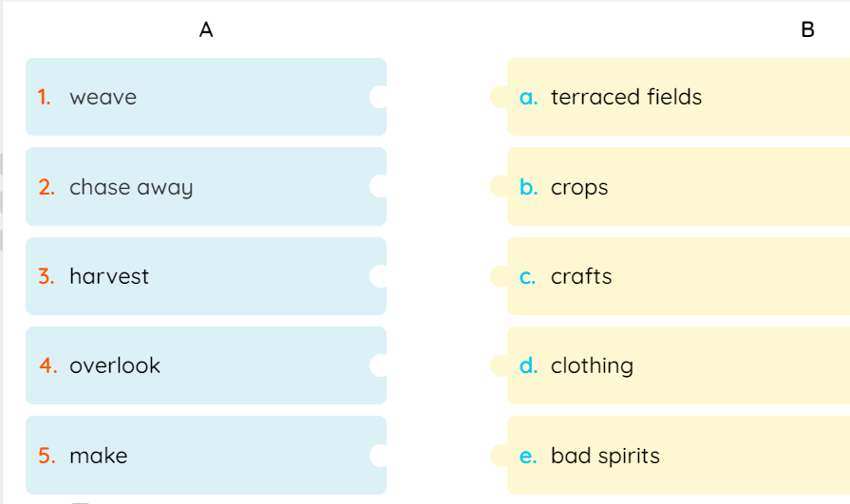
Procedure | - Teacher asks Ss to work individually to read the verbs/ verb phrases and the nouns carefully.  - Teacher asks Ss to do the exercise individually.  - Ss match a verb or verb phrase in A with a noun or noun phrase in B.  - Teacher confirms the correct answers as a class.
Outcome | Answer key: 1. d 2. e 3. b 4. a 5. C

Activity 4 : Vocabulary (8 minutes)
Goal | The activity aims at helping students provide Ss with more practice on the use of some key words and phrases in a new context.
Input | Complete the sentences with the words and phrases from the box.  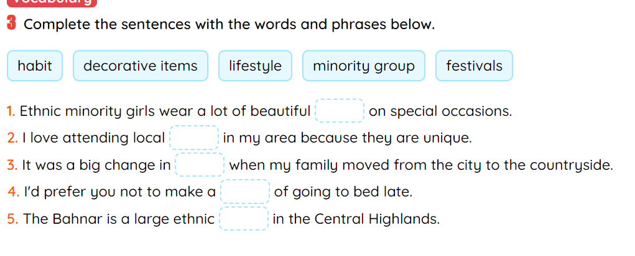
Procedure | - Teacher asks Ss to work in pairs.  - Teacher asks Ss to read the words in the box first and see if they remember their meanings.  - Ss read each sentence and decide which word or phrase from the box best fits in.  - Teacher confirms the answers as a class.  - Teacher highlights the key words in each sentence which helps Ss do the task.
Outcome | Answer key: 1. decorative items 2. festivals 3. lifestyle 4. habit 5. minority group

Activity 5 : Grammar ( 8 minutes)
Goal | The activity aims at helping Ss revise the use of articles, types of questions, countable and uncountable nouns.
Input | Choose the correct answer A, B, or C to complete each sentence.  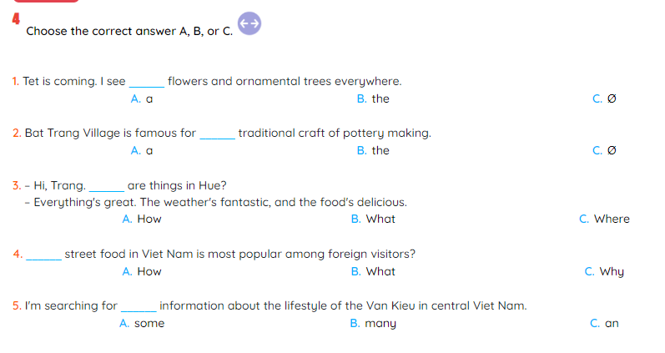
Procedure | - Teacher asks Ss to work in pairs.  - Ss read each sentence and decide which answer (A, B, or C) best completes the sentence.  - Teacher calls on some Ss to share their answers with the class.  - Teacher confirms the correct answers as a class.  - Teacher explains if necessary.
Outcome | Answer key: 1. C 2. B 3. A 4. B 5. A
Activity 6 : Grammar ( 8 minutes)
Goal | The activity aims at providing Ss with more practice on the use of the simple future tense.
Input | Use the correct forms of the verbs in brackets to complete the sentences.  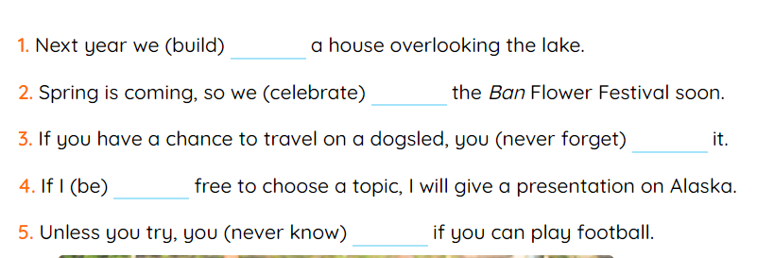
Procedure | - Teacher helps Ss revise the use of will for the simple future by writing two sentences on board, in which will is used in the situations Ss have learnt. For example, “I’ll do the painting tomorrow.’ and “If you agree, we will research about Mount Everest.”  - Teacher asks Ss to work individually.  - Teacher asks Ss to read the sentences and underline the signals that require the use of the future before they do the exercise.  - Teacher calls on some Ss to share their answers with the class.  - Teacher confirms the correct answers as a class.  - Teacher explains if necessary.  - Teacher may then call on some Ss to read aloud the correct sentences.
Outcome | Answer key: 1. will build 2. will celebrate 3. will never forget 4. am 5. will never know
Wrap-up: ( 4 minutes)
- Do exercises in the workbook.
- Prepare for Review 2 – Skills.

DUYỆT CỦA TỔ TRƯỞNG NGƯỜI SOẠN

Phạm Thị Tuyết Hoa Đỗ Thị Thu Hằng

