Week: 17
Period: 49
Date of teaching: 24/12/2024
REVIEW 2 - Lesson 2: Skills
Timing: 1 period (45 minutes)
I. Objectives
1.Knowledge: By the end of this unit students will be able to practice:
- reading for specific information about one’s favourite kind of music;
- talking about a visit to a lower secondary school;
- listening for specific information about a meal at a restaurant;
- writing a paragraph about a meal at a restaurant.
2. Competence
Students can develop communication skills and cultural awareness, be collaborative and supportive in pair work and teamwork, and actively join in class activities
3. Attitude
Students can develop self-study skills
II. Teaching aids (& materials)
Student book TA 7, ppt file,
III. Procedure
Activity 1: Warming-up (4 minutes)
Goal | The activity aims at creating an active atmosphere in the class before the lesson and leading into the new unit
Input | WHAT KIND OF MUSIC?
-Teacher lets Ss listen to some pieces of music and asks students to discuss what types of music they are.
- Students raise hands to answer.
- Teacher and students discuss the answers.
-Teacher checks the answers as a class.

Outcome | 1. Ss have an exciting atmosphere to start the lesson  2. Expected answers: 1. Country music 2. Classical music 3. Rock music  4. Hip hop music 5. Pop music
Activity 2: Cloze Text (6 minutes)
Goal | The activity aims at helping students practise reading specific information.
Input | 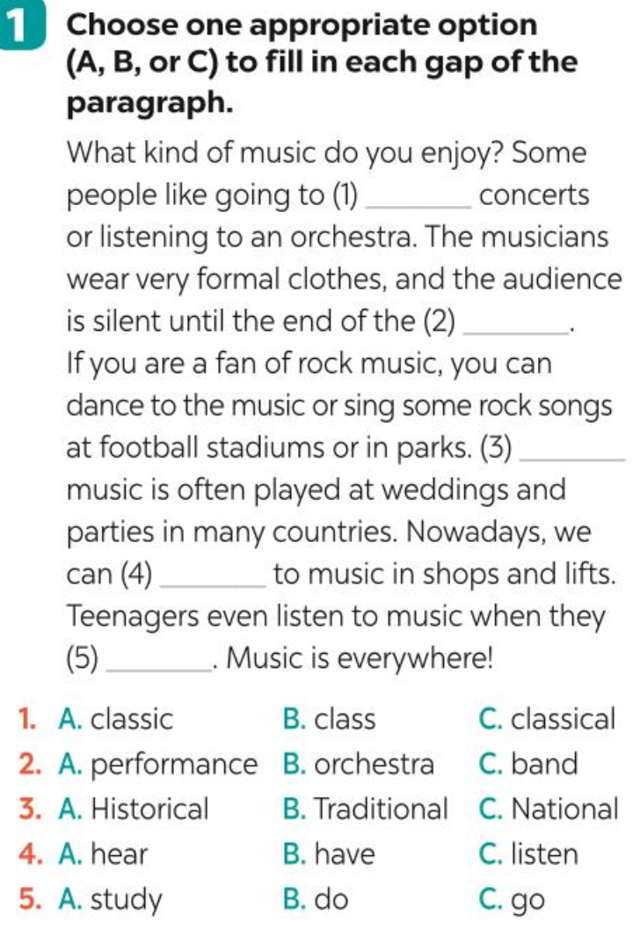
Procedure | – Teacher has Ss read the paragraph carefully and decides which option goes with which gap.  - Students read the text fully and choose the correct answers.  - Teacher asks students how they can choose the option.  - Teacher confirms the answers as a class.
Outcome | - Expected answer: 1. C 2. A 3. B 4. C 5. A

Activity 3 : Interviewing (8 minutes)
Goal | The activity aims at helping students practise asking and answering about a visit to a lower secondary school.
Input | 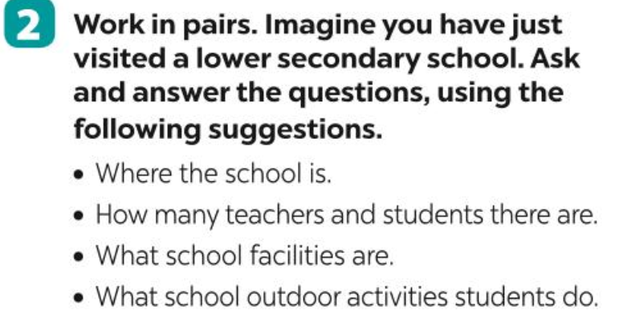
Procedure | -Teacher asks students to imagine that they have just visited a lower secondary school so that they can form their own ideas of where the school is, how many teachers and students there are, what school facilities are, what school outdoor activities students do.  -Let Ss read the questions to focus on the information they are going to answer.  - Students work in pairs, asking and answering the provided questions.  - Teacher calls on some pairs to report their answers for the class. Each pair may answer just one question to allow room for more pairs.  - Teacher checks the answers and adds more information if necessary.
Outcome | * Expected answer:  A: Can you tell me something about the school you’ve just visited?  B: Yes, of course.  A: Where is the school?  B: In Thap Muoi District.  A: How many teachers and students are there in the school?  B: There are about 40 teachers and 600 students.  A: What facilities does the school have?  B: It has a library, two labs, twelve classrooms …  A: ……..

Activity 4 : Listen & Tick. (5 minutes)
Goal | The activity aims at helping students practise listening for specific information
Input | 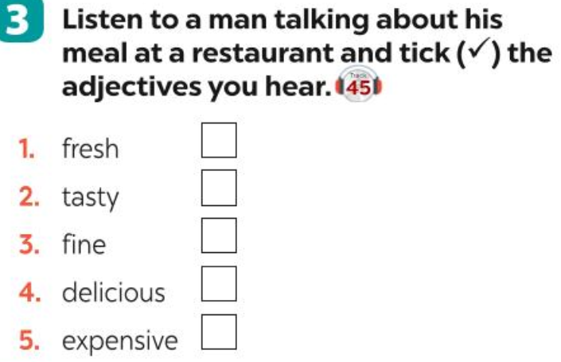
Procedure | -Teacher allows Ss some time to read the words/adjectives. Check if the words/adjectives are new or not. Check comprehension, if necessary.  Teacher plays the recording once.  - Students listen and do the task.  - Teacher allows students to share answers before discussing as a class.  - Teacher invites one student to read the words / adjectives they have ticked.
Outcome | * Expected answer: 1, 2, 4.  Audio script:  Last weekend, I went to a restaurant near my sister’s home. For a starter, I had a fresh salad. My main dish was fish. I really enjoyed the spices in it. The vegetables were good – very fresh and tasty. For dessert, I had an ice cream. It’s usually delicious but this time it wasn’t very sweet. So, I didn’t eat much. Then I had a glass of juice. I think the meal was OK.

Activity 5 : Gap fill ( 7 minutes)
Goal | The activity aims at helping ss practise listening for specific information
Input | 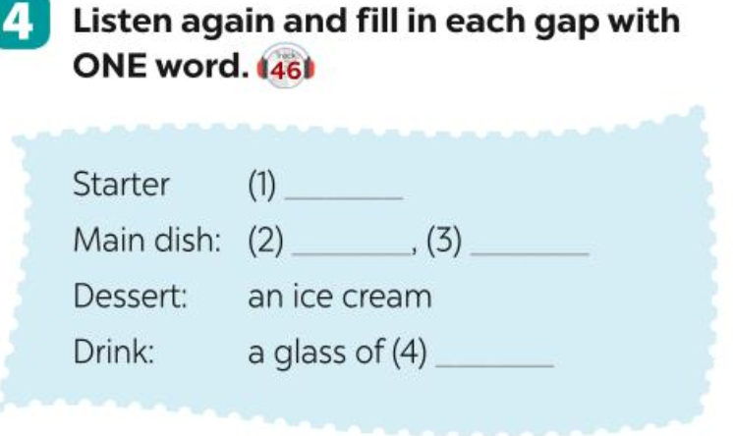
Procedure | - Teacher has Ss read the table. Draw their attention to the meanings of the words: starter, main dish, dessert, drink.  - Teacher plays the recording once or twice for the ss to complete the table.  - Students listen and do the task.  - Teacher allows students to share answers with their partners before discussing as a class.  - Teacher invites one student to read the words they have filled in.
Outcome | * Expected answer: 1. salad 2. fish 3. vegetables 4. juice
Activity 6 : Writing a paragraph about the meal they had at a restaurant ( 13 minutes)
Goal | The activity aims at helping ss practise writing a paragraph about a meal in a restaurant.
Input | 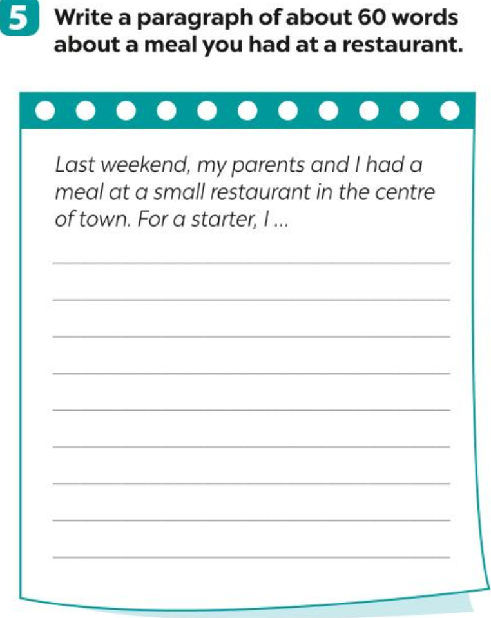
Procedure | - Teacher asks students to read the instructions and allow them some time to read the first sentence of the paragraph to think about the information they need to write.  - Students do the task individually.  - Teacher goes around and checks if they are doing the task correctly and offers help if needed.  - Teacher calls one or two volunteers to read aloud the paragraphs. Call for others’ comments.
Outcome | - Suggested paragraph:  Last weekend, my parents and I had a meal at a small restaurant in the centre of town. For a starter, I had a salad. It was fresh. My main dish included rice, beef, and vegetables. The beef was tasty, and the vegetables were fresh. For dessert, I had a big ice cream. Then I drank a glass of orange juice with ice. The meal was great.
Wrap-up: (2 minutes)
- Ask Ss to summarise what they have learnt in the lesson.
- Prepare for the 1st semester Test
*EVALUATION:
……………………………………………………………………………………………………………………………………………………………………………………………………………………………………………………………………………………………………………………………………………………………………………………………………………………………………………………………………
Week: 17
Period: 50
Date of teaching: 24/12/2024
REVIEW UNIT 1,2,

I. OBJECTIVES
By the end of this lesson, students will be able to:
1. Knowledge
- Revise the words related to hobbies and verbs of liking and disliking; healthy activities and health problems.
- Pronounce the sounds /ə/, /ɜ:/, /f/, /v/, correctly in isolation and in context;
- Revise the present simple tense to talk about liking, disliking.
- Revise how to ask for and give health tips.
2. Competences
- Develop communication skills about hobbies and healthy living.
- Be collaborative and supportive in pair work and teamwork
- Actively join in class activities
3. Qualities
- Develop self-study skills
- Raise students’ awareness of the need to keep their neighbourhood green.
II. TEACHING AIDS
1. Teacher: English book, extra-board, power point..
2. Students: English books, workbooks.
III. PROCEDURE
Write the letter A, B, C, or D on your answer sheet to indicate the word whose underlined part differs from the other three in pronunciation in the following question.
Question 9: A. invited B. loved C. used D. used
Question 10: A. today B. together C. melody D. work
Write the letter A, B, C, or D on your answer sheet to indicate the word that differs from the other three in the position of primary stress in the following question.
Question 11: A. donate B. rubbish C. sugar D. garden
Write the letter A, B, C, or D on your answer sheet to indicate the correct answer to each of the following questions.
Question 12: There isn’t__________ fruit juice in the fridge.
A. any B. some C. a D. an
Question 13: The film is not __________long as the film I watched last week.
A. but B. as C. to D. from
Question 14: I and my friends __________ trees last Sunday .
- plants B. plant C. planted D. planting
Question 15: Her idea is different __________ her friend’s.
- as B. from C. to D. same
Question 16: I went to see a __________ performance last night.
- music B. musically C. musician D. musical
Question 17: Mai is talking to Hoa about her community activities
Mai: Last week, I donated books and clothes to poor children in my village.
Hoa: ______________________ .
A. That’s a good idea B. You’re welcome
C. Sounds great work D. Not at all
Write the letter A, B, C, or D on your answer sheet to indicate the word(s) CLOSEST in meaning to the underlined word(s) in the following question.
Question 18: We helped the elderly do the cleaning last summer.
- young people B. old people C. sick people D. blind people
Write the letter A, B, C, or D on your answer sheet to indicate the word(s) OPPOSITE in meaning to the underlined word(s) in the following question.
Question 19: Healthy food and exercise help people keep fit.
A. unhealthy B. fresh C. delicious D. fast food
Write the letter A, B, C, or D on your answer sheet to indicate the underlined part that needs correction in each of the following questions.
Question 20: How much bananas do you eat every day?
A. day B. much C. eat D. do
Question 21: My hobby is sport, so I played sport every day.
- so B. is C. played D. My
Question 22: My mum doesn’t like watching films on TV. She loves go to the cinema.
A. she B. on C. watching D. go
Read the following passage and write the letter A, B, C, or D on your answer sheet to indicate the correct word or phrase that best fits each of the numbered blanks.
People in my city love good food and they often eat three meals (23)______ day : breakfast, lunch and dinner. At about 7.00 in the morning, they usually have a light breakfast with a bowl of pho or eel soup with some slices of toast. Sometimes they have a bowl of instant noodles or a plate of xoi (sticky rice) before going to work. Lunch often (24)_______ at about 11.30, and most of them have lunch at home. They often have fish, meat, and vegetables for lunch. Dinner often starts (25)_______ 8.00 in the -evening. It is the main meal of the day. People in my city often have rice with a lot of fresh vegetables and a lot of seafood or various kinds of meat. Then, they often eat (26)______ fruit and a glass of green tea. I think the food in my city is wonderful. It is light and full of fresh vegetables. It’s healthy and very tasty, too.
Question 23: A. a B. an C. some D. any
Question 24: A. start B. starts C. started D. is starting
Question 25: A. with B. on C. at D. in
Question 26: A. if B. although C. unless D. some
Read the following passage and write the letter A, B, C, or D on your answer sheet to indicate the correct answer to each of the questions.
Bun bo Hue is one of the most popular dishes in Viet Nam. It comes from Hue - the old capital city of Viet Nam. Its main ingredients are rice vermicelli (a thin form of rice noodles called bun) and slices of beef. Nowadays, we can find bun bo Hue nearly everywhere in Viet Nam. We can enjoy it for all kinds of meals during the day and even for a late-night snack.
Bun bo Hue has a special taste - a balance of spicy, salty, and sweet flavours. To make its broth, people stew beef bones and beef shank with lemongrass, shrimp sauce, sugar, and spicy chili oil. People often eat bun bo Hue with ox tail, pork knuckle, and a variety of herbs... It's really delicious!
Tell me about a particular dish where People enjoy it for all kinds of meals where you live!
Posted by Minh at 10:30 p.m.

Question 27: Where does Bun Bo Hue come from?
A. Hue B. Da Nang C. Ha Noi D. Can Tho
Question 28: What are its main ingredients?
A. rice and slices of beef
B. rice and slices of pork
C. rice vermicelli and slices of beef
D. rice vermicelli and slices of pork
Question 29: Where can we find bun bo Hue?
A. Hue City B. Ho Chi Minh City
C. Ha Noi D. everywhere in Viet Nam
Question 30: How do people make the broth for bun bo Hue?
A. They stew beef bones and beef shank with shrimp sauce and spicy chili oil.
B. They stew beef bones and beef shank with lemongrass, sugar and spicy chili oil.
C. They stew beef bones and beef shank with lemongrass, shrimp sauce and sugar.
D. They stew beef bones and beef shank with lemongrass, shrimp sauce, sugar and spicy chili oil.
SECTION B
I. Finish each of the following sentences in such a way that it means the same as the sentence printed before it. Write your answers on your answer sheet. (0,5 point)
Question 1: My sister loves talking to her friends in her free time.
My sister enjoys ______________________________________ .
Question 2: My school is not the same as your school.
Your school is_________________________________________

…………………………………………………………………………………….
Week: 17
Period: 51
Date of teaching: 27/12/2024
REVISION

I. OBJECTIVES:
By the end of the lesson, students will be able to:
- Knowledge:
By the end of the lesson, students will be able to:
- Will be able to revise pronunciation, vocab, grammar unit 3
- Answer the questions about the community service in the book.
- pronounce correctly the sounds /edː/ and /id/.
* Grammar: The past simple
2. Competences:
Recycle the language from the previous units.
- Consolidate and apply what they have learnt from unit 1 to unit 3 by doing various activities and exercises.
3. Qualities:
having positive attitude while working in individual or with their classmate.
II. TEACHING AIDS
1. Teacher: Text books, pictures, planning, …
- Grade 7 textbook, Unit 3.
- Smart TV/Pictures, sets of word cards
- sachmem.vn
2. Students: Text books, notebooks, posters, ….
III. PROCEDURES:
Write the letter A, B, C, or D on your answer sheet to indicate the word whose underlined part differs from the other three in pronunciation in the following question.
Question 9: A. today B. together C. melody D. work
Question 10: A. watered B. cooked C. cleaned D. volunteered
Write the letter A, B, C, or D on your answer sheet to indicate the word that differs from the other three in the position of primary stress in the following question.
Question 11: A. musician B. composer C. instrument D. delicious
Write the letter A, B, C, or D on your answer sheet to indicate the correct answer to each of the following questions.
Question 12: Nga: Lan: My eyes are tired.
Hoa: ………………..
A. Great. B. That’s a good idea.
C. You can use eye drops. D. No problem.
Question 13: Tien Quan Ca is the national …………… of Viet Nam.
A. folk song B. anthem C. pop song D. poem
Question 14: The sun …………….. in the west every evening..
A. set B. sets C. to set D. setting
Question 15: She really wants to raise money …………….. poor children.
A. with B. of C. about D. for
Question 16: ………………did your brother start painting? - Three years ago.
A. What B. Where C. Who D. When
Question 17: She …………… a new mobile phone two days ago.
A. buy B. buys C. bought D. will buy
Write the letter A, B, C, or D on your answer sheet to indicate the word(s) CLOSEST in meaning to the underlined word(s) in the following question.
Question 18: My sister always eats healthy food and does exercise to stay in shape.
A. keep fit B. be active C. put on weight D. relax
Write the letter A, B, C, or D on your answer sheet to indicate the word(s) OPPOSITE in meaning to the underlined word(s) in the following question.
Question 19: Making pottery is interesting because it’s a creative activity.
A. difficult B. unusual C. boring D. healthy
Write the letter A, B, C, or D on your answer sheet to indicate the underlined part that needs correction in each of the following questions.
Question 20: I think that pop music is not as intersting from rock music.
A. music B. think C. from D. is

Question 21: There are some cars in our city. Too many. I don’t like it.

A. some B. There C. like D. our
Question 22: How much bananas do you eat every day?
A. day B. much C. eat D. do
Read the following passage and write the letter A, B, C, or D on your answer sheet to indicate the correct word or phrase that best fits each of the numbered blanks.
I’m happy to hear you are in Viet Nam again. This time, how about (23) …………… a water puppet show? I’m sure you’ll like it. Is Saturday evening Ok for you? It’s (24)…..……….. 115 Nguyen Hue Street, Tan Binh District. The show (25)…………. at 8 p. m , so let’s meet at 7:45 outside the theatre. I hope we’ll have a happy time together.
Looking forward to (26) ……………….. you there.
Have a nice day!
Question 23: A. rehearsing B. watching C. doing D. practicing
Question 24: A. on B. in C. at D. for
Question 25: A. begins B. begin C. finish D. present
Question 26: A. see B. to see C. seen D. seeing
Read the following passage and mark the letter A, B, C, or D on your answer sheet to indicate the correct answer to each of the questions
The first reason why many families do volunteer work is that they feel satisfied and proud. The feeling of fulfillment comes from helping the community and other people. In addition, volunteering is a great way for families to have fun and feel closer. But many people say they don’t have time to volunteer because they have to work and take care of their family. If’s that the case, try rethinking some of your free time as a family. You could select just one or two projects a year and make them a family tradition. For instance, your family can make and donate gift baskets for the old homeless people on holidays. Your family can also spend only one Saturday morning a month collecting rubbish in your neighborhood.
Question 27. How do people often feel when they volunteer?
A. happy B. satisfied
C. proud D. satisfied and proud
Question 28. Why don’t they have time to volunteer?
A. Because they have to work.
B. Because they have to work and take care of their family.
C. Because they don’t have money.
D. Because they have to take care of their family.
Question 29. How can they help the old homeless people?
A. donate gift baskets. B. cook
C. provide classes D. donate food
Question 30. Is collecting rubbish in the neighborhood an example of volunteer work?
A. No, it isn’t . B. No, he isn’t.
C. Yes, it is D. Yes, he is.
Section B
I. Finish each of the following sentences in such a way that it means the same as the sentence printed before it. Write your answers on your answer sheet. (0,5 point)
Question 1: My brother loves talking to his friends in her free time.
My brother enjoys ....................................................................................................
Question 2: My bag is not the same as your bag.
Your bag is………………………………………………………………………………

DUYỆT CỦA TỔ TRƯỞNG NGƯỜI SOẠN

Phạm Thị Tuyết Hoa Đỗ Thị Thu Hằng

