**Week: 15**

**Period: 43**

**Date of teaching: 10/12/2024**

**UNIT 6: A VISIT TO A SCHOOL**

**Lesson 3: A CLOSER LOOK 2 + LANGUAGE FOCUS 3, 4**

**Timing: 1 period (45 minutes)**

**I. Objectives**

**1. Knowledge:** By the end of this unit students can:

**a.** Skills:

- *Main skill:*

Writing: write sentences using *at, in, on*

*- Sub- skill*:

Speaking: ask and answer the questions using “When, Where”

**2. Competence**

Students can use prepositions *at, in, on* for time or places.

**3. Attitude**

Students can develop communication skills and creativity, be collaborative and supportive in pair work and teamwork and actively join in class activities

**II. Teaching aids (& materials)**

Student book TA 7, ppt file

**III. Procedure**

**Activity 1: Setting the scene (10 minutes)**

|  |  |
| --- | --- |
| **Goal** | The activity aims at creating an active atmosphere in the class before the lesson and leading into the new unit |
| **Input** | **GAME: SIMON SAYS** |
| **Procedure** | T explains the game rules:  T tells students what they must do using prepositions of place, beginning with “Simon says”. (E.g. Simon says: put the pen in the pencil case; Simon says: sit on the chairs, Simon says: put your ruler on the table, …)  Ss listen to the rules of the game and do the actons by following T’s saying. |
| **Outcome** | Ss have an exciting atmosphere to start the lesson. |

**Activity 2: Identifying and remembering the using of** *at, on* **and** *in* **for time (5 minutes)**

|  |  |
| --- | --- |
| **Goal** | The activity aims at helping Ss practise using *at, in* and *on* in sentences and in context. |
| **Input** | |  |  |  | | --- | --- | --- | |  | **Form** | **Meaning** | | Prepositions of time | 1. in | used to show a period of time that is longer or shorter than a day (*e.g. in the morning, in 2020, …*) | | 2. on | used to show a day or part of a day (*e.g. on Monday, on January 18th , on Christmas Day, …*) | | 3. at | used to show a point of time (*e.g. at six o’clock, at noon, at break time, …*) |   **1. Complete the sentences, using suitable prepositions of time.** *(Ex 1, p.63)*  1. In England, schools usually start _____ 9 a.m. and finish _____4 p.m.  2. They built our school a long time ago, maybe _____ 1990.  3. We are going to visit Thang Long Lower Secondary School _____ January.  4. The school year usually begins _____ September 5th every year.  5. The children like playing badminton and football _____ their break time. |
| **Procedure** | - Ask Ss to read the sentences carefully and choose the best answers on their own, then swap with their partners.  - Ss do the exercise as instructed.  - Ss share their answers and discuss the reasons why they have chosen them.  - Nominate some Ss to read their answers in front of the whole class T check and correct their answers. |
| **Outcome** | 1. Ss identify and remember the using of at, in or on  ***Answer Key:***  1. at , at  2. in  3. in  4. on  5. in |

**Activity 3: Practising WH – question: When (5 minutes)**

|  |  |
| --- | --- |
| **Goal** | The activity aims at giving Ss further practice on asking and answering the quesions*.* |
| **Input** | **2. Work in pairs. Ask and answer the questions about your school.** *(Ex 2, p.63)*  1. When does your school year start?  2. When do you have English lessons?  3. When do you usually celebrate Teachers' Day?  4. When are you going to finish the school year? |
| **Procedure** | T has Ss read the questions individually. Remind them that the questions with ***when*** are used to ask about time and the prepositions of time (in, on, at) are used in the answers.  Ss work in pairs to ask and answer the questions.  T calls some pairs to ask and answer the questions in front of the class.  T confirms the answers and gives feedback. |
| **Outcome** | ***Answer Key:***  1. My school year starts in September  2. I have English lessons on Mon day and Friday  3. I usually celebrate Teacher's Day on November 20th  4. I am going to finish the school year in May |

**Activity 4: Identifying and remembering the using of** *at, on* **and** *in* **for place (5 minutes)**

|  |  |
| --- | --- |
| **Goal** | The activity aims at helping Ss practise using *at, in* and *on* in sentences and in context. |
| **Input** | |  |  |  | | --- | --- | --- | | Prepositions of place | 1. in | inside something / a place (e.g. *in the classroom, in the school garden, in the playground*) | | 2. on | on the surface of something (e.g. *on the board, on the wall, on the second floor*) | | 3. at | shows a certain point (e.g. *at home, at school, at work*) |   **3. Complete the sentences with at, in, or on.***(Ex 3, p.63)*  1. Her classroom is _____ the third floor of that building.  2. When I'm at school, my parents are _____ work.  3. Look! The students are playing football _____the classroom.  4. My little sister usually has lunch _____ school.  5. The most beautiful posters are _____ the wall the staffroom. |
| **Procedure** | - Ask Ss to read the sentences carefully and choose the best answers on their own, then swap with their partners.  - Ss do the exercise as instructed.  - Ss share their answers and discuss the reasons why they have chosen them.  - Nominate some Ss to read their answers in front of the whole class T check and correct their answers. |
| **Outcome** | ***Answer Key:***  1. on  2. at  3. in  4. at  5. on in |

**Activity 5: Practising WH – question: Where (5 minutes)**

|  |  |
| --- | --- |
| **Goal** | The activity aims at giving Ss further practice on asking and answering the quesions*.* |
| **Input** | **4. Work in pairs. Look at the pictures and answer the questions**. *(Ex 4, p.64)*  1. Where does Mrs Hien teach maths?  2. Where do the students water the flowers?  3. Where is the boy writing?  4. Where do they sing English songs on Teachers' Day? |
| **Procedure** | T has Ss read the instructions of the activity to understand what they are going to do. Remind them that questions with ***where*** are used to ask about places and prepositions of place (*at, on, in*) are used in the answers. Check comprehension.  T asks Ss to do the exercise in pairs.  Then call on some pairs to ask and answer the questions in front of the class.  T confirms the answers and gives feedback. |
| **Outcome** | ***Answer Key:***   1. She teaches Maths in the classroom  2. They water the flowers in the school garden  3. The boy is writing on the board  4. They sing English sóng on Teacher's Day at school |

**Activity 6: Practising the prepositions of time and place. ( 5 minutes)**

|  |  |
| --- | --- |
| **Goal** | The activity aims at giving Ss further practice using prepositions of time and place. |
| **Input** | 5. **Complete the passage with at, on, or in. Then discuss in groups which prepositions express time and which ones express place.** *(Ex 5, p.64)*  Tom's mother is at home, but she is not (1) _______ the kitchen. She usually waters the vegetables in the garden (2) _______ the morning. Tom's father is (3)_______ work, but he isn't in his office at the moment. It is his lunch break and he is (4)_______ a travel agent's, looking at holiday brochures. Tom is usually at school at this time, but he has a bad cold today. He has nothing to do but lying (5)_______ the sofa and looking at the posters (6) __________ the wall. |
| **Procedure** | T has one or two Ss say how the prepositions of time and place are used. Then ask them to read the instructions of the activity to understand what they are going to do.  Ss do the task individually.  T lets Ss discuss in groups and decide which prepositions express time and which ones express place. T goes around and corrects mistakes or gives help when necessary.  T calls on some Ss to share their answers in front of the class. If time allows, select one or two Ss to read the complete passage in front of the class. T and other Ss comment. |
| **Outcome** | ***Answer Key:***  1. in 2. in 3. at 4. at 5. in 6. on |

**Wrap-up:(5 minutes)**

- Summarise the main points of the lesson.

- Make sentences about themselves, using the prepositions of time and place.

- Prepare Communication on page 64.

- Ask Ss to do exercises 3 and 4 in Looking Back

Exercise 3

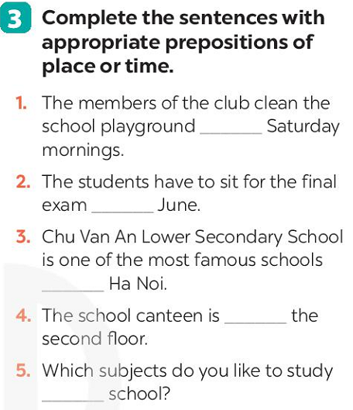

Exercise 4

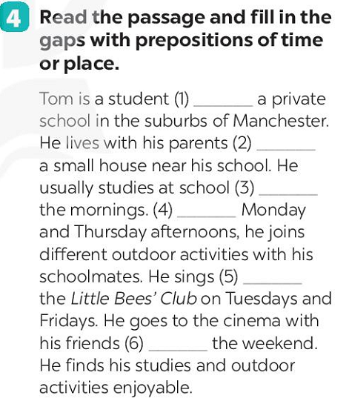

**Reference activities:**

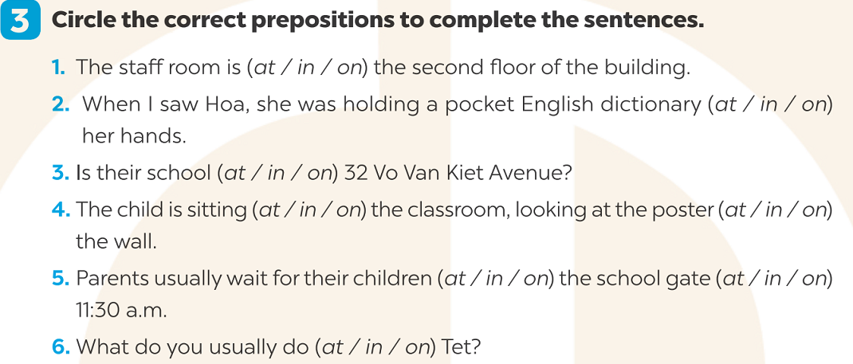

**\*EVALUATION:**

………………………………………………………………………………………………………………………………………………………………………………………………………………………………………………………………………………………………………………………………………………………………………………………………………………………………………………………………………………………………………………………………………………………………………………………………

**Week: 15**

**Period: 44**

**Date of teaching: 10/12/2024**

**UNIT 6: A VISIT TO A SCHOOL**

**Lesson 4: COMMUNICATION**

**Timing: 1 period (45 minutes)**

**I. Objectives**

**1. Knowledge:** By the end of this unit students can:

**a.** Skills:

- *Main skill*

Speaking: introduce their school to friend and comparing 2 schools.

*- Sub- skill*:

Listening: listen for specific information about school.

**b.**Language:

Vocabulary: revise vocabulary related to topic A visit to a school

Grammar: structures to ask for details.

**2. Competence**

Students can tell everyone about their school and outline some vocabulary and grammar items related to the topic

**3. Attitude**

Students can develop communication skills and creativity, be collaborative and supportive in pair work and teamwork and actively join in class activities

**II. Teaching aids (& materials)**

Student book TA 7, ppt file

**Activity 1: Setting the scene (5 minutes)**

|  |  |
| --- | --- |
| **Goal** | The activity aims at creating an active atmosphere in the class before the lesson and leading into the new unit |
| **Input** | **GAME: CONVERSATION REARRANGING** |
| **Procedure** | - T divides the class into 4 groups. T delivers a set of sentences in a conversation to each group.  - Ss will have to work in groups to arrange the sentences to make a meaningful conversation. The group with the fastest correct conversation will be the winner.  - T allows Ss to cross check first.  - T plays the recording to check. |
| **Outcome** | ***Reference conversation*** |

**Activity 2: Introducing ways of asking and answering for details. (5 minutes)**

|  |  |
| --- | --- |
| **Goal** | The activity aims at introducing ways to ask and answer for details. |
| **Input** | Can you tell me more?  Can you tell me how?  Can you tell me why?  **1. Listen and read the conversation. Pay attention to the highlighted sentence.**  **Mi**: Are you doing anything this Sunday?  **Phong**: Not really.  **Mi**: Would you like to go with us to Binh Minh Lower Secondary School?  **Phong**: Sounds great! ***Can you tell me more?***  **Mi**: We'll leave at 7 a.m. My friends David and Nick are coming too. |
| **Procedure** | T lets Ss listen to the examples in Ex 1 in the book.  T draws their attention to the form of ways to ask for details.  T and Ss discuss the form of ways to ask for details.  T confirms the answers and gives feedback. |
| **Outcome** | Ss identify and remember the using of “Can you tell me more?” to ask for details |

**Activity 3: Practising asking and answering about asking for details. (10 minutes)**

|  |  |
| --- | --- |
| **Goal** | The activity aims at helping Ss get to know the ways to ask for details. |
| **Input** | **2. Work in pairs. Ask and answer questions about your visit to a famous school. Use "Can you tell me more?' or "Can you tell me why?, "Can you tell me how?".** |
| **Procedure** | - T has students read the instructions to understand what they are going to do.  - Ss work in pairs to ask and answer questions about their visit to a famous school.  - T then asks Ss to exchange their answer among class.  - T gives feedback. |
| **Outcome** | - Ss can ask for details  Model conversation:  I: Are you doing anything this weekend?  Mai Anh: Not really.  I: Would you like to go with us to Ha Long Bay?  Mai Anh: Sounds great! Can you tell me more?  I: We'll leave at 8 a.m. My friends Linh and Nhi are coming too. |

**Activity 4: Practicing more on asking for details. (10minutes)**

|  |  |
| --- | --- |
| **Goal** | - The activity aims at teaching Ss brainstorm ideas about things they want to show their friends at school. |
| **Input** | **3. Imagine that some overseas friends are planning to visit your school. Make a list of what you want to show them, then fill in the note.** |
| **Procedure** | - T has Ss read the instructions to understand what they are going to do.  - Ss work as individuals.  - Ss discuss in groups to exchange ideas.  - T goes around and offers help, if necessary.  - Teacher gives Ss the correct answers. |
| **Outcome** | ***List of what you want to show:***  Library  Principal office  Soccer field  Playground  Garden  Science laboratories  Computer rooms |

**Activity 5: Practising on asking and answering** **questions about their plans (10 minutes)**

|  |  |
| --- | --- |
| **Goal** | The activity aims at teaching Ss give chances to practice asking and answering questions about their plans. |
| **Input** | **4. Work in pairs. Ask and answer questions about your plan.** |
| **Procedure** | - T gives instructions and asks Ss to read the example to understand how to start and end the conversation.  Ss work in pairs, ask and answer questions about their plans.  T allows Ss to share their answers with other pairs.  T calls some pairs to act out the conversations in front of the class. T and other Ss comment. |
| **Outcome** | ***Example***:  A: I'm going to show them the school library.  B: Sounds good. Can you tell me why?  A: I want them to see our learning resources. I think they're very modern. |

**Activity 5: Practising conversation (10 minutes)**

|  |  |
| --- | --- |
| **Goal** | The activity aims at teaching Ss practice talking about their school. |
| **Input** | **4. Work in groups. Read the passage and complete the table about a high school in the UK. Then discuss and fill in the information about your school.** |
| **Procedure** | - T has read the instructions to understand what they are going to do. Remind them that they have to read the passage and fill the information from the passage in the column of Wilson High School.  - Ask Ss to look at the table to understand what information they need to find in the passage (e.g. number of students and teachers, the subjects they study and the facilities the school has).  - Ss read the passage individually and fill in the column of Wilson High School.  - T asks Ss to work in pairs and compare.  - T calls on one or two Ss to tell about Wilson School in front of the class.  - Ss work in groups, discuss and fill in the table information about their school.  - T goes around and listen, make suggestions and corrections if needed  Wilson High School is for students aged 11 -16 in London. It has about 1,000 students and 100 teachers. The school has some modern science laboratories, computer rooms, a large library, a sports hall, and an activity studio. The students study many different subjects such as English, literature, maths, science, etc. They also study extra subjects and get involved in projects, use school resources and take part in a number of outdoor activities and school trips.    Example: There are about 1,000 students in Wilson High School. They are between 11 and 16 years old. Our school has about 900 students. We are between 11 and 14 years old. |
| **Outcome** | ***Aswer Key***:   |  |  |  | | --- | --- | --- | |  | **Wilson High School** | **Your school** | | Number of students & teacher | 1,000 students and 100 teachers | 650 students and 50 teachers | | Subject | English, literature, maths, science, etc | English, literature, maths, science, etc | | School facilities | science laboratories, computer rooms, a large library, a sports hall, and an activity studio | science laboratories, computer rooms, a large library, a sports hall, and an activity studio | |

**Wrap-up: (5 minutes)**

Ask Ss to summarise what they have learnt in the lesson. Have Ss look at the objectives written on the board at the beginning of the lesson and tick the objectives they can do.

Teacher has Ss say what they have learnt in the lesson:

Vocabulary of school activities or school facilities

Ways to ask for details

Prepare Skills 1 on page 66.

**\*EVALUATION:**

………………………………………………………………………………………………………………………………………………………………………………………………………………………………………………………………………………………………………………………………………………………………………………………………

**Week: 15**

**Period: 45**

**Date of teaching: 13/12/2024**

**UNIT 6: A VISIT TO A SCHOOL**

**Lesson 5: SKILLS 1**

**Timing: 1 period (45 minutes)**

**I. Objectives**

**1. Knowledge:** By the end of this unit students can:

**a.** Skills:

Reading:scanning for specific information about a famous school

Speaking: Talking about one’s school

**b.** Language:

Vocabulary: use vocabulary about school

Grammar: use the present simple tense to talk about a famous school

**2. Competence**

Students can tell everyone about the school that is popular in their area

**3. Attitude**

Students can develop communication skills and creativity, be collaborative and supportive in pair work and teamwork and actively join in class activities

**II. Teaching aids (& materials)**

Student book TA 7, p.p.t file

**III. Procedure**

**Activity 1: Setting the scene (5 minutes)**

|  |  |
| --- | --- |
| **Goal** | The activity aims at teaching Ss enhance students’ skills of cooperating with teammates. |
| **Input** | **GAME: WHO IS FASTER?** |
| **Procedure** | - T divides the class into 2 teams.  - Members from each team take turns to the board to write the correct school facilities under the posters.  - The team with more correct answers will be the winner.  Ss play the game in team mode.  T and Ss discuss the answers.  T confirms the answers and gives feedback. |
| **Outcome** | 1. Ss have an exciting atmosphere to start the lesson  ***Answer key:***  1. school playground  2. school gym  3. computer room  4. school library  5. swimming pool |

**Activity 2: Teaching new words (5 minutes)**

|  |  |
| --- | --- |
| **Goal** | The activity aims at providing students with vocabulary and helping students well-prepared for the reading and speaking tasks. |
| **Input** | 1. found (v) : thành lập  2. well-known = famous (adj) : nổi tiếng  3. royal (adj) : thuộc về hoàng gia  4. projector (n) : máy chiếu |
| **Procedure** | - Teacher introduces the vocabulary.  - T asks Ss to get the meaning in context and try to make up sentences with these words  - T and Ss discuss the answers.  - T confirms student’s answers and checks their pronunciation and gives feedback.  - T use “What and Where”to check vocabulary |
| **Outcome** | 1. Ss have certain vocabulary for the reading and speaking tasks.  2. Four new words |

**Activity 2: Activating Ss' knowledge of the topic (5 minutes)**

|  |  |
| --- | --- |
| **Goal** | The activity aims at activating Ss' knowledge of the topic of the reading text. |
| **Input** | **1. Look at the pictures and answer the questions.** (*Ex 1, p. 66*)    1. What can you see in the picture?  2. What do you know about them? |
| **Procedure** | - T asks Ss to work in pairs, look at the pictures and answer the questions. Encourage them to focus on the details / ideas of the photos (color of the buildings, locations, surroundings, …)  - Ss work in pairs, look at the pictures and answer the questions.  - T and Ss discuss the questions and answers.  - T accepts all students’ questions. |
| **Outcome** | 1. Ss express their thoughts about the topic famous school  ***Answer key:***  1. I can see a school  2. This is Quoc Hoc - Hue, an old school of Viet Nam in Hue. |

**Activity 3: Reading skill – scanning to get specific information to answer the questins. (5 minutes)**

|  |  |
| --- | --- |
| **Goal** | The activity aims athelping Ss develop the reading skill for specific information. |
| **Input** | **2. Read the passage and answer the questions** (*Ex 2, p. 66)*  Quoc Hoc - Hue is one of the oldest schools in Viet Nam. It is on the bank of the Huong River, in Hue. It was founded in 1896. It used to be a school for children from rich and royal families. Well-known people such as Ho Chi Minh, Vo Nguyen Giap, Xuan Dieu studied there.  Nowadays, the school is for gifted students. They are intelligent and study hard. They have to pass an entrance exam to enter the school. The school has over 50 classrooms with TVs, projectors, and computers. It also has a swimming pool, a library, two English labs, four computer rooms, and many other modern facilities. The school is one of the largest and most beautiful schools in Viet Nam.  1. Where is Quoc Hoc - Hue?  2. Who were some of the well-known students of the school?  3. What are the students like?  4. How many English labs does it have? |
| **Procedure** | - T asks Ss to open the book, read through the text and do the task. T sets a time limit for Ss to read and do the task individually.  - Ss read the text and do the task individually.  - T allows Ss to share their answers in pairs before discussing as a class and encourages them to give evidence.  - T calls some Ss to give the answer, explains which sentence gives them the information. |
| **Outcome** | 1. Ss can read and get the specific information to answer.  ***Answer key:***  1. It’s in Hue (on the bank of the Huong River).  2. They were Ho Chi Minh, Vo Nguyen Giap, Xuan Dieu.  3. They are intelligent and hard-working.  4. It has two English labs. |

**Activity 4: Summary the information (10 minutes)**

|  |  |
| --- | --- |
| **Goal** | The activity aims athelping Ss develop the skill of reading for specific information (scanning). |
| **Input** | **3. Read the passage again and complete the table. Then report it to the class.** (*Ex 3,p.66)*    *Example*: The name of the school is Quoc Hoc - Hue. |
| **Procedure** | - T can set a longer time limit for Ss to read the text again.  - T asks Ss to look at the table to understand what information they have to find in the text (e.g. the name, the location, the students, and the school facilities). Explain that this task helps them focus on the information they are going to find in the text.  - Ss work in individuals to fill the table.  - T allows Ss to compare their answers in groups before reporting to the class.  - T selects one or two Ss to report the information in the table in front of the class. The class listens and comments. |
| **Outcome** | 1. Ss master the ways to read for specific information  ***Answer key:***   |  |  | | --- | --- | | **Name** | Quoc Hoc – Hue | | **Location** | on the bank of the Huong River, in Hue | | **Students** | intelligent and hard-working | | **School facilities** | over 50 classrooms (with TVs, projectors, computers), a swimming pool, a library, two English labs, four computer rooms, and many other modern facilities. | |

**Activity 5: Speaking skill. (5 minutes)**

|  |  |
| --- | --- |
| **Goal** | The activity aims athelping Ss form the ideas for their speaking. |
| **Input** | **4. Work in pairs. Answer the questions with the information in the table.** (*Ex 4, p.66*)  1. What's the full name of the school?  2. Where is it?  3. What are the students like?  4. What facilities does the school have? |
| **Procedure** | -T has Ss read the instructions to identify how to do the task, then asks them to look at the table to understand what information they are going to discuss (e.g. the name, location, students, and the facilities of their school).  - T asks Ss to work in pairs, asking and answering questions about the information in the table.  - T can go around helping weaker Ss.  - T calls on some pairs to practise in front of the class. |
| **Outcome** | 1. Ss can read the information and answer the questions  ***Answer key:***  1. The full name of the school is Hung Vuong Lower Secondary School  2. It is at 120, Hung Vuong Street  3. The students are hard-working and intelligent  4. It has 20 classrooms, one library, 2 computer rooms, one gym and one garden |

**Activity 6: A long talking. (5 minutes)**

|  |  |
| --- | --- |
| **Goal** | The activity aims atteaching Ss use what they practice to give a long talk about their school. |
| **Input** | **5. Work in groups. Tell about your school. You can use the suggestions in 4 (full name, location, students and school facilities).** (*Ex 5, p.66*) |
| **Procedure** | - T has Ss work in groups, talk about their schools based on the information from Task 4.  - Ss work in groups to do the task.  - T goes around helping Ss.  - After finishing, T can call some groups to give presentations in front of the class.  - T allows Ss to give comments for their friends and vote for the most interesting and informative presentation.  - Ss give comments for their friends and vote for the most interesting and informative presentation.  - T and Ss discuss the presentations.  - T gives feedback and comments. |
| **Outcome** | 1. Ss master the ways to give a speaking or presentation.  ***Expected answer:***  The full name of the school is Vinh Thoi Primary School. It is at Vinh Thoi Village. The students are intelligent and lovely. It has 24 classrooms, one library, 2 computer rooms, 1 English labs and one garden |

**Wrap-up: (5 minutes)**

- Ask Ss to summarise what they have learnt in the lesson.

- Have Ss look at the objectives written on the board at the beginning of the lesson and tick the

objectives they can do.

- Prepare Skills 2 on page 67.

**\*EVALUATION:**

………………………………………………………………………………………………………………………………………………………………………………………………………………………………………………………………………………………………………………………………………………………………………………………………………………………………………………………………………………………………………………………………………………………………………………………………

**DUYỆT CỦA TỔ TRƯỞNG NGƯỜI SOẠN**

Phạm Thị Tuyết Hoa Đỗ Thị Thu Hằng